ASP.Net Core 3

Module 3: Blazor

Student Lab Manual

Instructor Edition (Book Title Hidden Style)

**Conditions and Terms of Use**

**Microsoft Confidential**

This training package is proprietary and confidential, and is intended only for uses described in the training materials. Content and software is provided to you under a Non-Disclosure Agreement and cannot be distributed. Copying or disclosing all or any portion of the content and/or software included in such packages is strictly prohibited.

The contents of this package are for informational and training purposes only and are provided "as is" without warranty of any kind, whether express or implied, including but not limited to the implied warranties of merchantability, fitness for a particular purpose, and non-infringement.

Training package content, including URLs and other Internet Web site references, is subject to change without notice. Because Microsoft must respond to changing market conditions, the content should not be interpreted to be a commitment on the part of Microsoft, and Microsoft cannot guarantee the accuracy of any information presented after the date of publication. Unless otherwise noted, the companies, organizations, products, domain names, e-mail addresses, logos, people, places, and events depicted herein are fictitious, and no association with any real company, organization, product, domain name, e-mail address, logo, person, place, or event is intended or should be inferred.

© 2019 Microsoft Corporation. All rights reserved.

**Copyright and Trademarks**

© 2019 Microsoft Corporation. All rights reserved.

Microsoft may have patents, patent applications, trademarks, copyrights, or other intellectual property rights covering subject matter in this document. Except as expressly provided in written license agreement from Microsoft, the furnishing of this document does not give you any license to these patents, trademarks, copyrights, or other intellectual property.

Complying with all applicable copyright laws is the responsibility of the user. Without limiting the rights under copyright, no part of this document may be reproduced, stored in or introduced into a retrieval system, or transmitted in any form or by any means (electronic, mechanical, photocopying, recording, or otherwise), or for any purpose, without the express written permission of Microsoft Corporation.

For more information, see Use of Microsoft Copyrighted Content at  
<http://www.microsoft.com/en-us/legal/intellectualproperty/Permissions/default.aspx>

Internet Explorer, Microsoft, SQL Server, Visual Studio, and Windows are either registered trademarks or trademarks of Microsoft Corporation in the United States and/or other countries. Other Microsoft products mentioned herein may be either registered trademarks or trademarks of Microsoft Corporation in the United States and/or other countries. All other trademarks are property of their respective owners.

Contents

Lab 2: Implementing Blazor 1

Exercise 1: Get started with ASP.NET Core Blazor 3

Exercise 2: Components and Layout 8

Exercise 3: Event Handling and Data Binding 14

Exercise 4: Routing 29

Exercise 5: State Management 44

# Lab 2: Implementing Blazor

#### Introduction

The aim of this exercise is to explore implementing an application using the new application model introduced under ASP.Net Core 3 called Blazor.

Important

**Blazor WebAssembly in preview**

Blazor Server is supported in ASP.NET Core 3.0. Blazor WebAssembly is in preview for ASP.NET Core 3.1.

#### Objectives

After completing this lab, you will be able to:

* Understand the basic principles of Blazor.
* Have a full functional Blazor application

#### Prerequisites

None

#### Scenario

In this scenario, we will explore implementing an online Pizza Delivery application.

#### System Requirements

To complete this lab, you need:

* Install the latest [.NET Core 3.0 SDK](https://dotnet.microsoft.com/download/dotnet-core/3.0) release
* Install the [Blazor WebAssembly](https://docs.microsoft.com/en-us/aspnet/core/blazor/hosting-models?view=aspnetcore-3.0#blazor-webassembly) template by installing the [.NET Core 3.1 Preview SDK](https://dotnet.microsoft.com/download/dotnet-core/3.1) and then running the following command in a command shell:

dotnet new -i Microsoft.AspNetCore.Blazor.Templates::3.1.0-preview1.19508.20

.Net Core ClI

* Install Microsoft Visual Studio 2019 (16.3 or later)

#### Estimated Time to Complete This Lab

8 hours

Exercise 1: Get started with ASP.NET Core Blazor

#### Objectives

In this exercise, you will:

* Create a new ASP.NET Core 3 Blazor
* Understand the structure of a Blazor project

#### Scenario

Create a new ASP.Net Core 3 Blazor application and run it.

Task 1: Create the New Project

1. Install the latest [Visual Studio](https://visualstudio.com/vs/) with the **ASP.NET and web development** workload.
2. Create a new project.

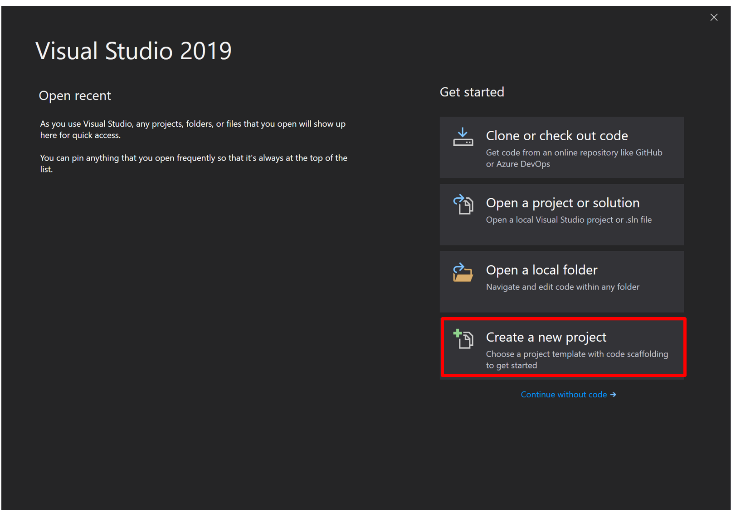

1. Select **Blazor App**. Select **Next**.

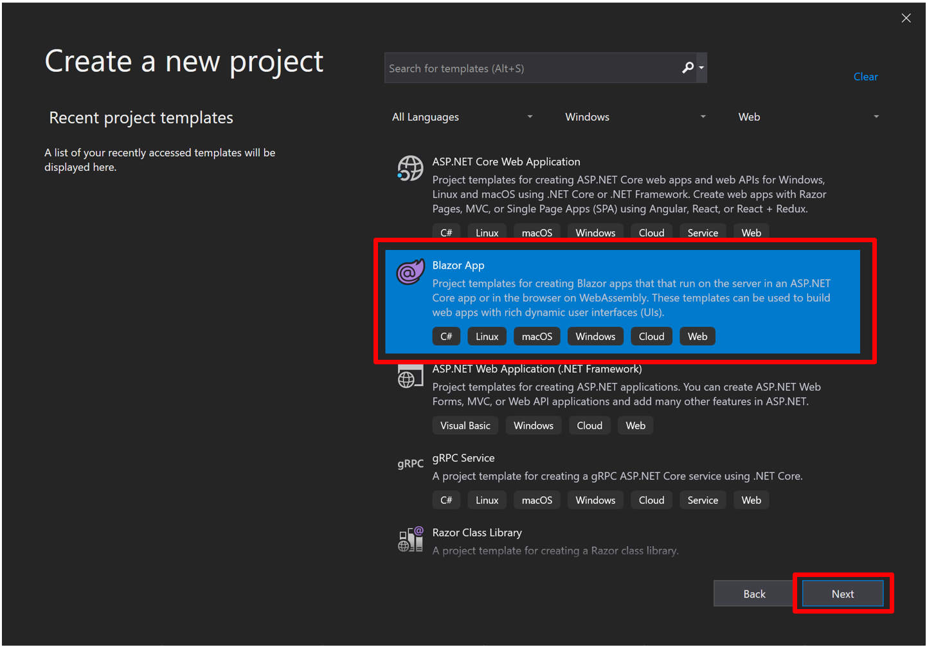

1. Provide a project name in the **Project name** field or accept the default project name. Confirm the **Location** entry is correct or provide a location for the project. Select **Create**. Call the Application “MyFirstBlazorApp”.

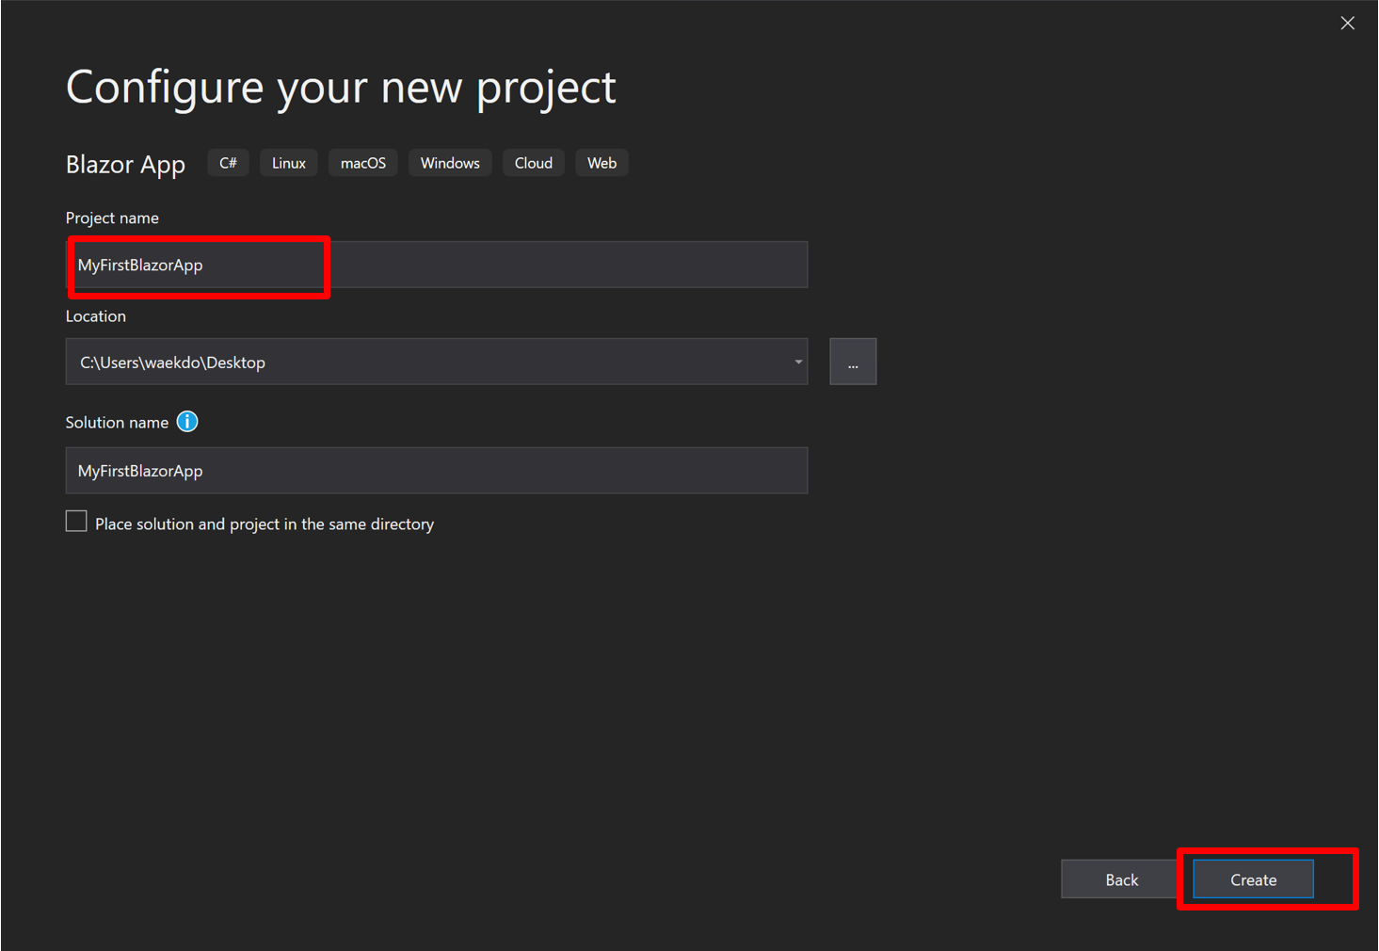

1. For a Blazor WebAssembly experience, choose the **Blazor WebAssembly App** template. For a Blazor Server experience, choose the **Blazor Server App** template. For this exercise we will go with the Blazor Server Option. Select **Create**. For information on the two Blazor hosting models, Blazor Server and Blazor WebAssembly, see [ASP.NET Core Blazor hosting models](https://docs.microsoft.com/en-us/aspnet/core/blazor/hosting-models?view=aspnetcore-3.0).

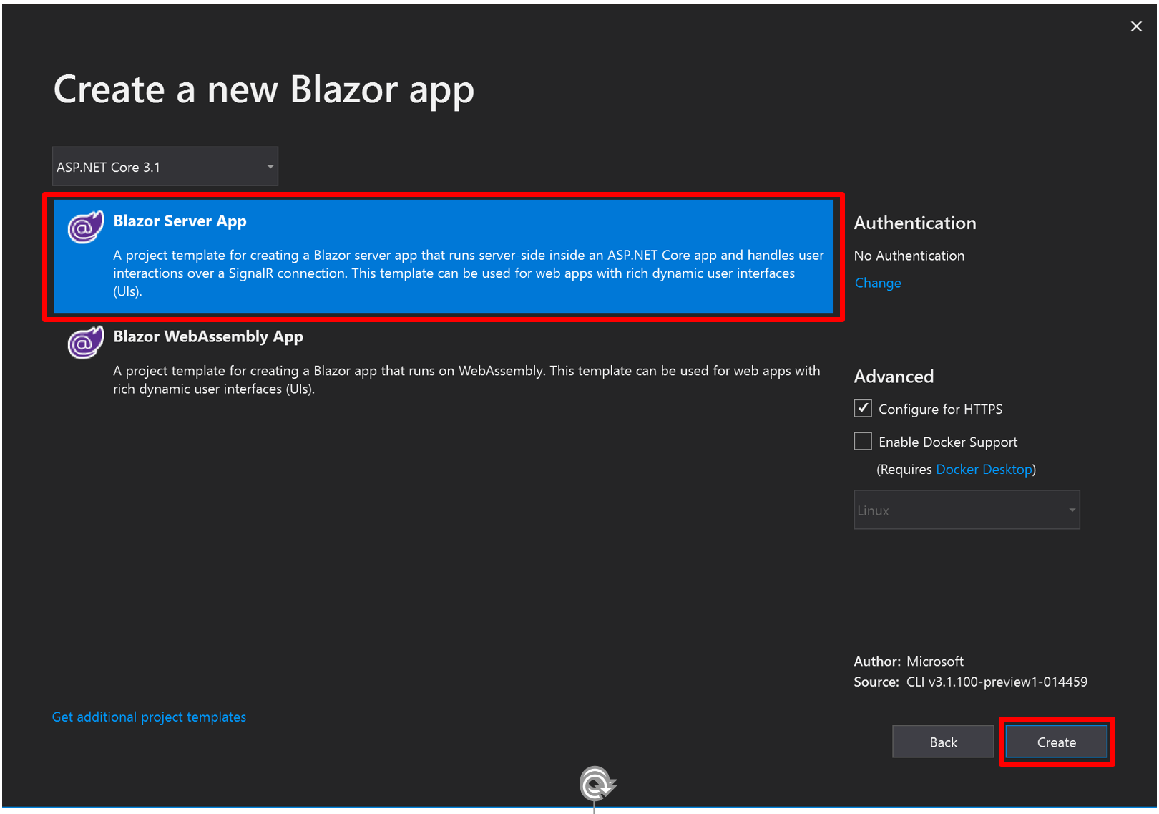

Important

**If you have ASP.NET 3.0 selected then you will only the Blazor Server App option**

Blazor Server is supported in ASP.NET Core 3.0. Blazor WebAssembly is in preview for ASP.NET Core 3.1.

1. Press **F5** to run the app.

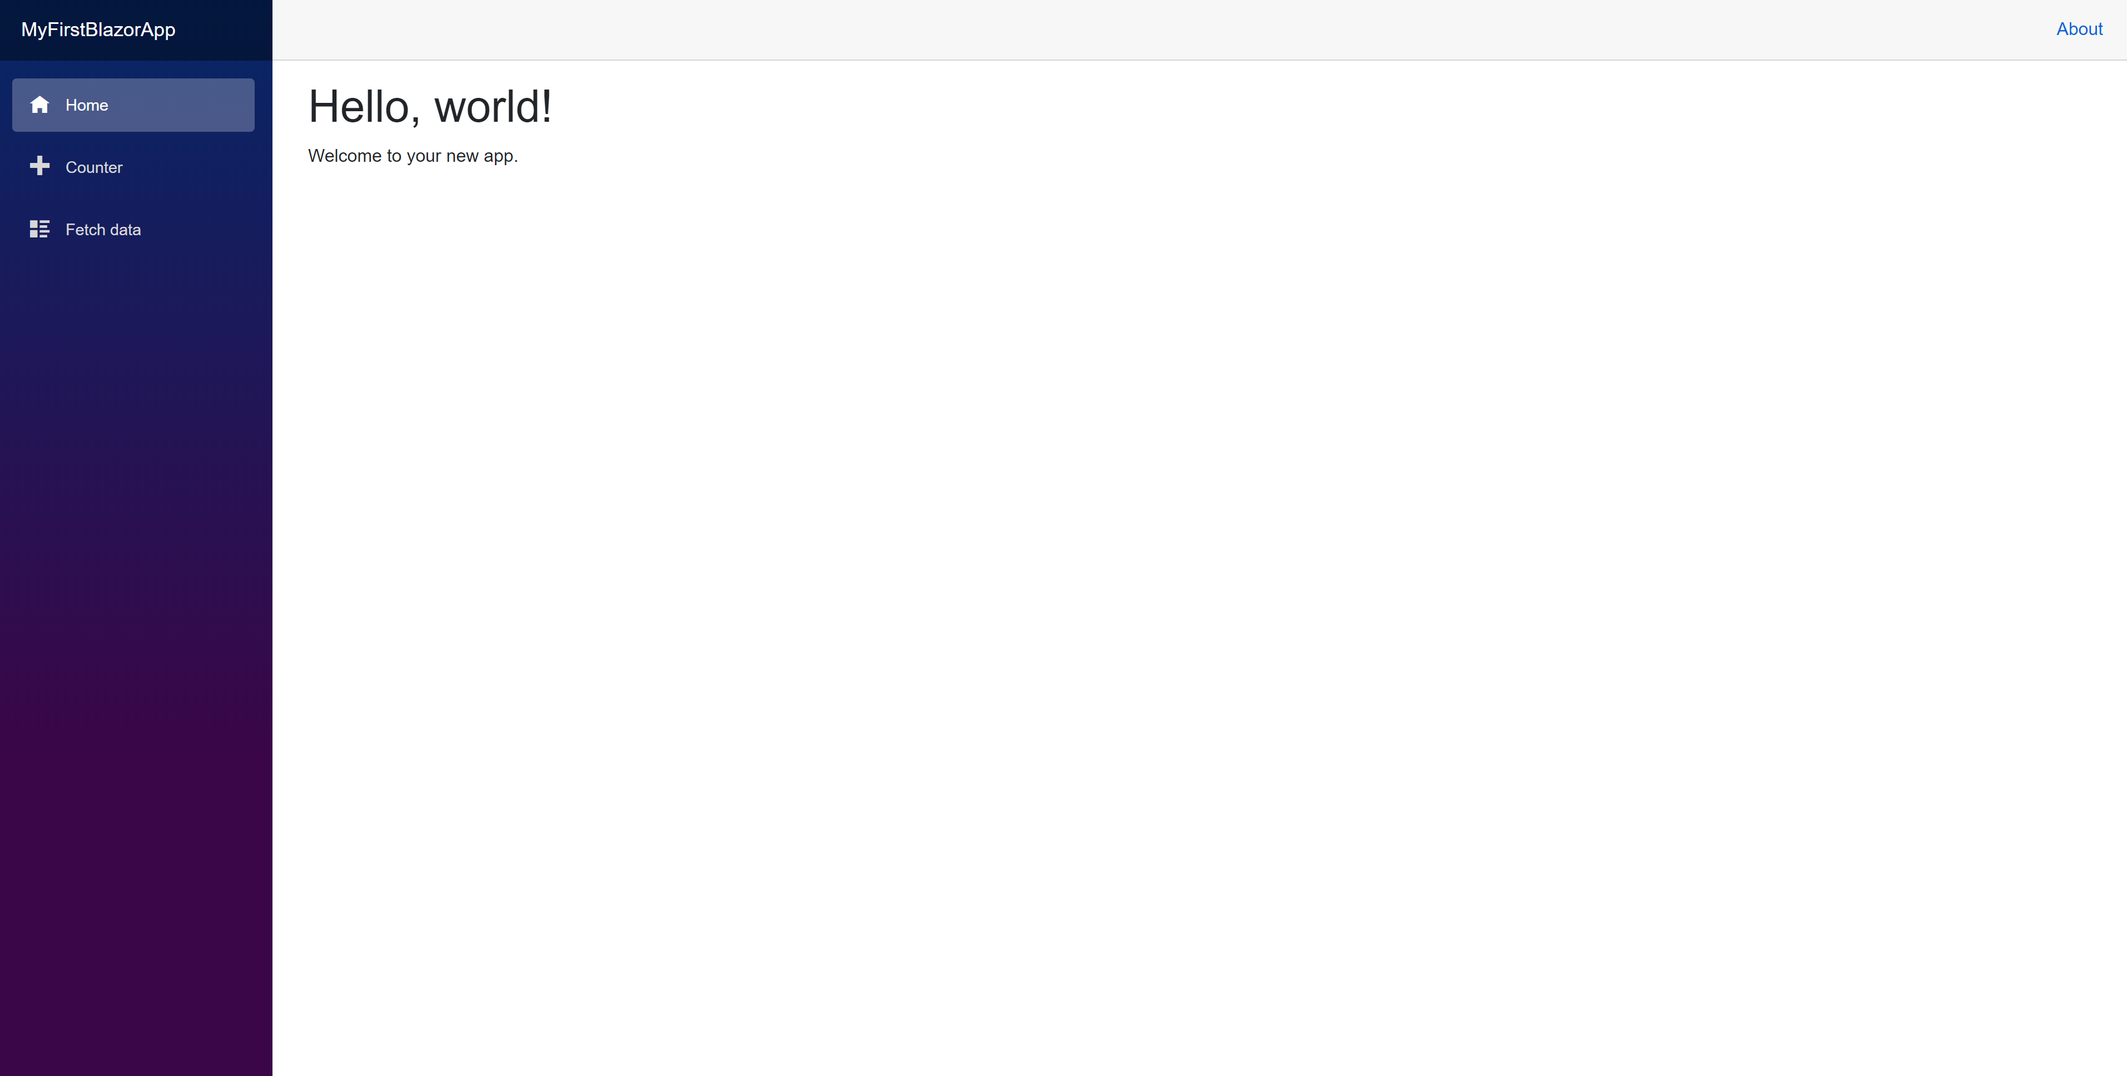

Exercise 2: Components and Layout

#### Objectives

In this exercise, you will:

* Create a Blazor Component
* Create a Layout Component

#### Scenario

You will get started with building a pizza store app using Blazor. You will add a component that displays the list of available pizza specials. You will also introduce a layout component to define a top bar with a branding logo and a nav link for the home page.

Task 1: Create a Blazor Component

1. Start by opening the solution file **BlazingPizza.sln** located under **\Labs\Module 03 - Blazor\Components and Layouts\Begin**.

The solution already contains four projects:

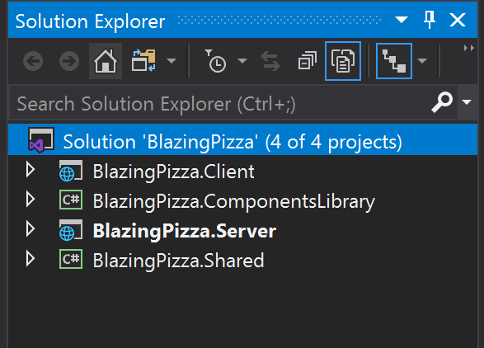

* **BlazingPizza.Client**: This is the Blazor project. It contains the UI components for the app.
* **BlazingPizza.Server**: This is the ASP.NET Core project hosting the Blazor app and also the backend services for the app.
* **BlazingPizza.Shared**: Shared model types for the app.
* **BlazingPizza.ComponentsLibrary**: A library of components and helper code to be used by the app in later sessions.

The **BlazingPizza.Server** project should be set as the startup project.

When you run the app, you'll see that it currently only contains a simple home page.

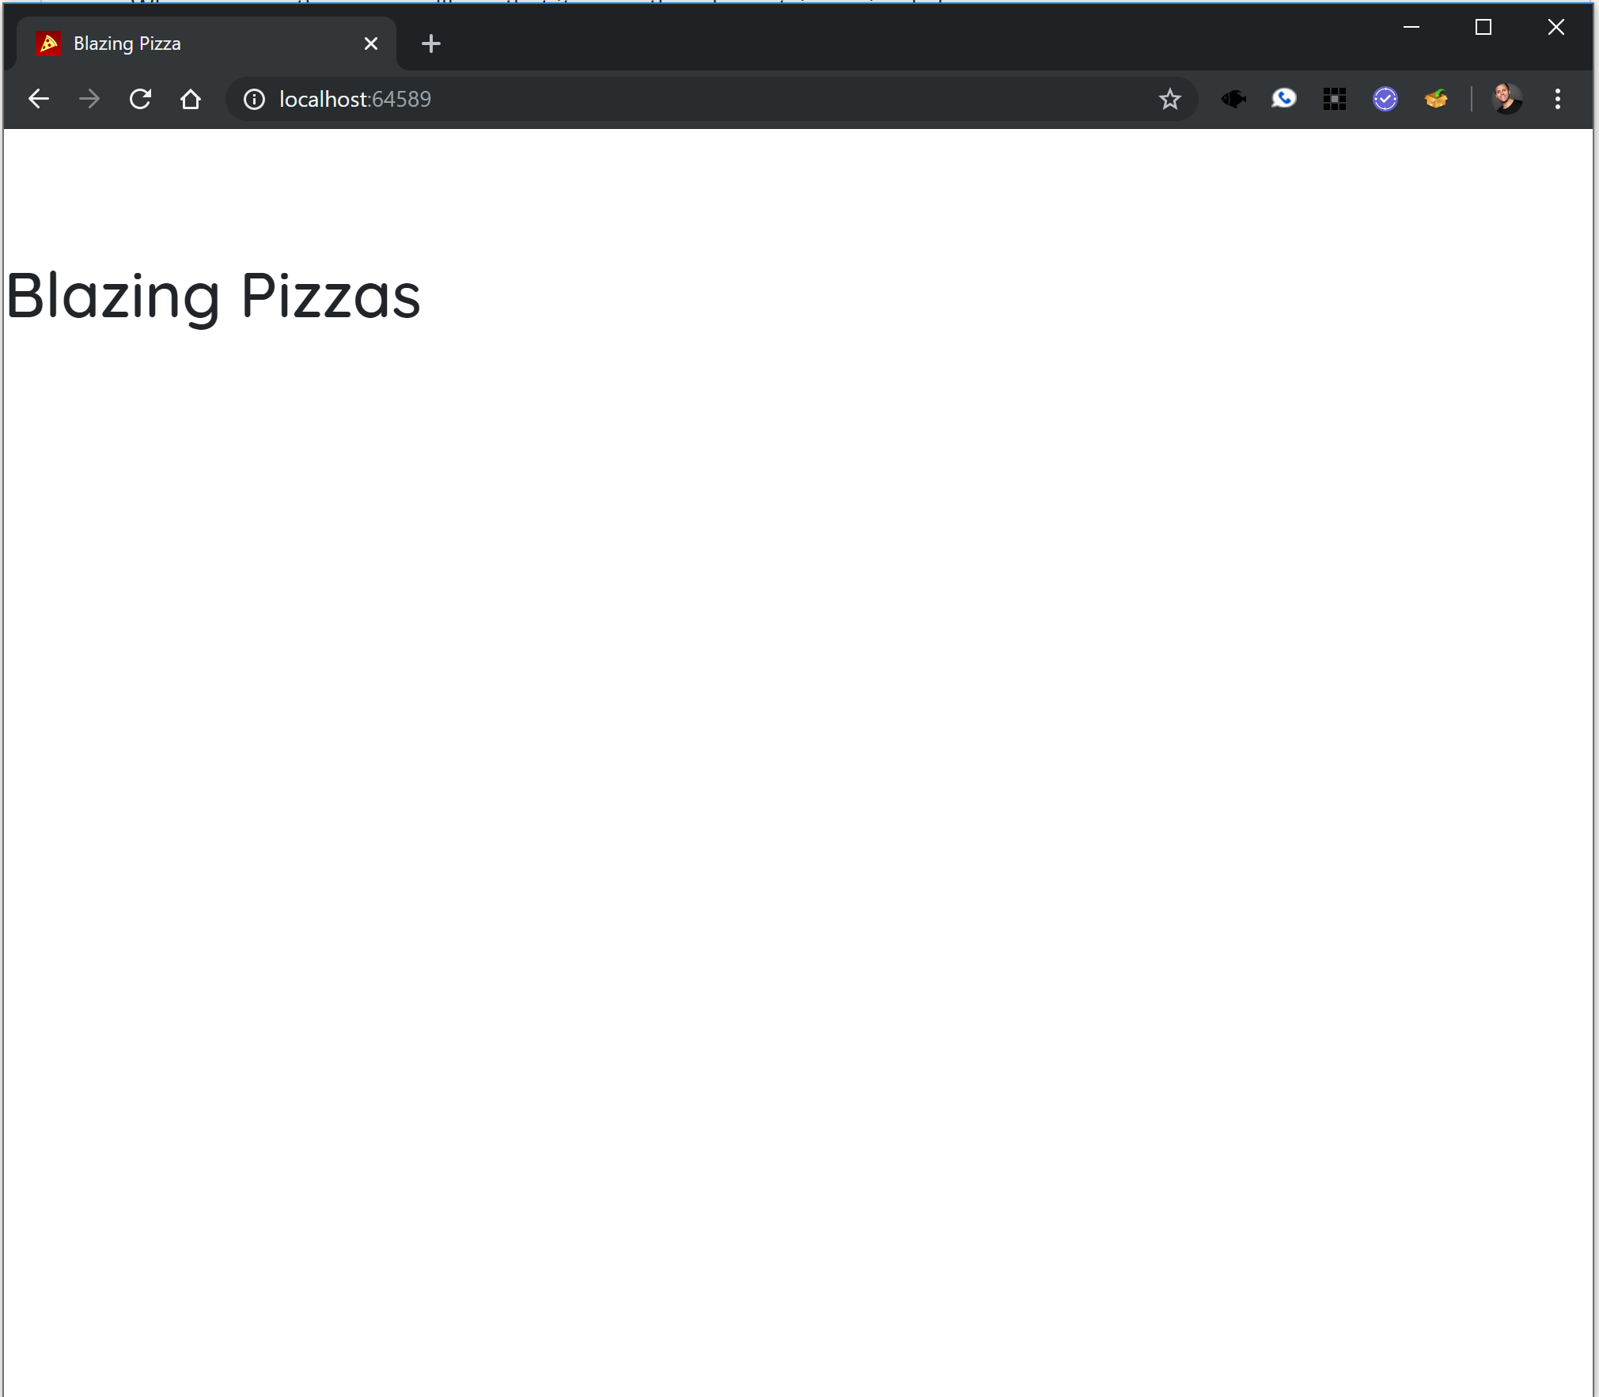

Open Pages/Index.razor in the **BlazingPizza.Client** project to see the code for the home page.

@page "/"

<h1>Blazing Pizzas</h1>

The home page is implemented as a single component. The @page directive specifies that the Index component is a routable page with the specified route.

1. Next we'll update the home page to display the list of available pizza specials. The list of specials will be part of the state of the Index component.

Add a @code block to Index.razor with a list field to keep track of the available specials:

@code {

List<PizzaSpecial> specials;

}

The code in the @code block is added to the generated class for the component. The PizzaSpecial type is already defined for you in the Shared project.

1. To get the available list of specials we need to call an API on the backend. Blazor provides a preconfigured HttpClient through dependency injection that is already setup with the correct base address. Use the @inject directive to inject an HttpClient into the Index component.

@page "/"

@inject Http

The @inject directive essentially defines a new property on the component where the first token specified the property type and the second token specifies the property name. The property is populated for you using dependency injection.

1. Override the OnInitializedAsync method in the @code block to retrieve the list of pizza specials. This method is part of the component lifecycle and is called when the component is initialized. Use the GetJsonAsync<T>() method to handle deserializing the response JSON:

@code {

List<PizzaSpecial> specials;

protected async override Task OnInitializedAsync()

{

specials = await HttpClient.GetJsonAsync<List<PizzaSpecial>>("specials");

}

}

The /specials API is defined by the SpecialsController in the Server project.

1. Once the component is initialized it will render its markup. Replace the markup in the Index component with the following to list the pizza specials:

<div class="main">

<ul class="pizza-cards">

@if (specials != null)

{

@foreach (var special in specials)

{

<li style="background-image: url('@special.ImageUrl')">

<div class="pizza-info">

<span class="title">@special.Name</span>

@special.Description

<span class="price">@special.GetFormattedBasePrice()</span>

</div>

</li>

}

}

</ul>

</div>

1. Run the app by hitting Ctrl-F5. Now you should see a list of the specials available.

[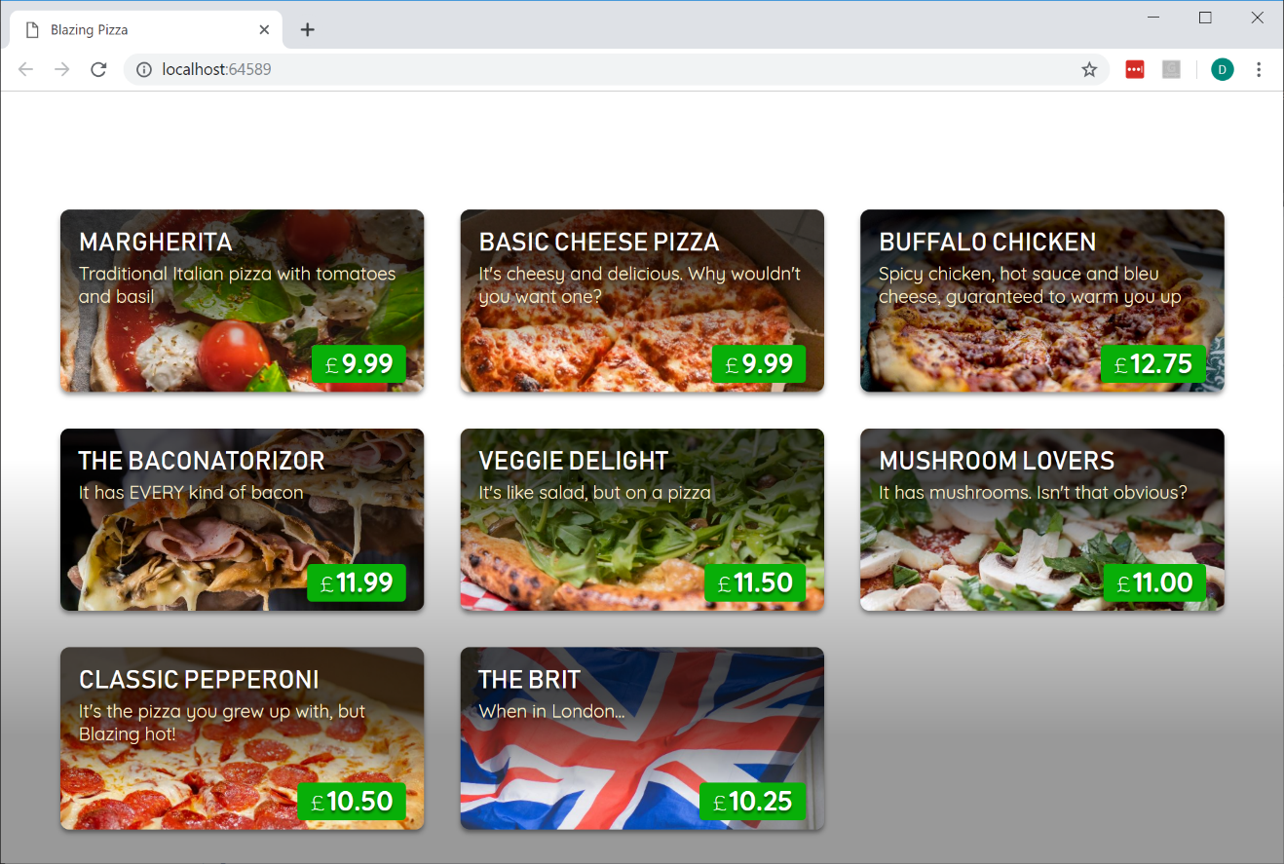](https://user-images.githubusercontent.com/1874516/57006743-1602e400-6b98-11e9-96cb-ff4829cf459f.png)

Task 2: Create a Layout Component

1. Next we'll set up the layout for app. Layouts in Blazor are also components. They inherit from LayoutComponentBase, which defines a Body property that can be used to specify where the body of the layout should be rendered. The layout component for our pizza store app is defined in **Shared/MainLayout.razor** under **BlazingPizza.Client** project.

@inherits LayoutComponentBase

<div class="content">

@Body

</div>

1. To see how the layout is associated with your pages, look at the <Router> component in App.razor. Notice the DefaultLayout parameter which determines the layout used for any page that doesn't specify its own layout directly. You can also override this DefaultLayout on a per-page basis. To do so, you can add directive such as @layout SomeOtherLayout at the top of any .razor page component. However, you don't need to do so in this application.
2. Update the MainLayout component to define a top bar with a branding logo and a nav link for the home page:

@inherits LayoutComponentBase

<div class="top-bar">

<img class="logo" src="img/logo.svg" />

<NavLink href="" class="nav-tab" Match="NavLinkMatch.All">

<img src="img/pizza-slice.svg" />

<div>Get Pizza</div>

</NavLink>

</div>

<div class="content">

@Body

</div>

The NavLink component is provided by Blazor. Components can be used from other components, which is done by specifying an element with the component's type name along with attributes for any component parameters.

The NavLink component is the same as an anchor tag, except that it adds an active class if the current URL matches the link address. NavLinkMatch.All means that the link should be active only when it matches the entire current URL (not just a prefix). We'll

examine the NavLink component in more detail in a later session.

1. Run the app by hitting Ctrl-F5. With our new layout our pizza store app now looks like this:

[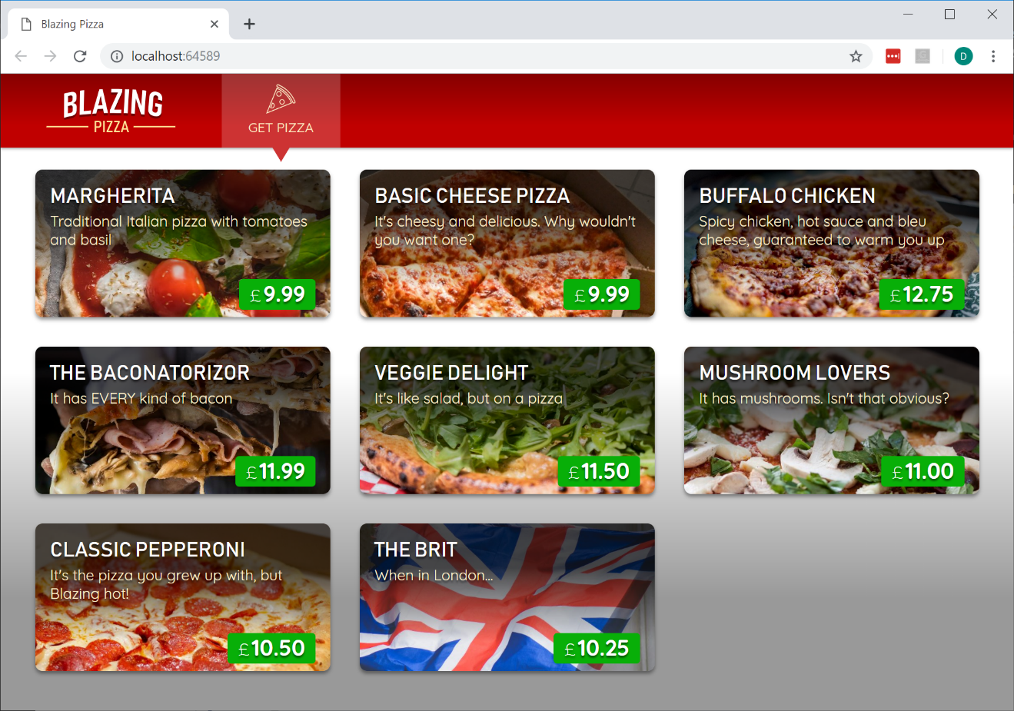](https://user-images.githubusercontent.com/1874516/57006730-e81d9f80-6b97-11e9-813d-9c35b62efa53.png)

Exercise 3: Event Handling and Data Binding

#### Objectives

In this exercise, you will:

* Learn how to handle DOM UI Events
* Learn how to pass Component Parameters
* Learn how to implement Data Binding
* Learn how to implement Component Events

#### Scenario

We'll update the pizza store app to enable users to customize their pizzas and add them to their order.

Task 1: Handle DOM UI Events

1. Start by opening the solution file **BlazingPizza.sln** located under **\Labs\Module 03 - Blazor\Events and Data Binding\Begin**.
2. When the user clicks a pizza special, a pizza customization dialog should pop up to allow the user to customize their pizza and add it to their order. To handle DOM UI events in a Blazor app, you specify which event you want to handle using the corresponding HTML attribute and then specify the C# delegate you want called. The delegate may optionally take an event specific argument, but it's not required.

In BlazingPizza.Client/Pages/Index.razor add the following @onclick handler to the list item for each pizza special:

@foreach (var special in specials)

{

<li @onclick="@(() => Console.WriteLine(special.Name))" style="background-image: url('@special.ImageUrl')">

<div class="pizza-info">

<span class="title">@special.Name</span>

@special.Description

<span class="price">@special.GetFormattedBasePrice()</span>

</div>

</li>

}

1. Run the app and check that the pizza name is written to the browser console whenever a pizza is clicked.

[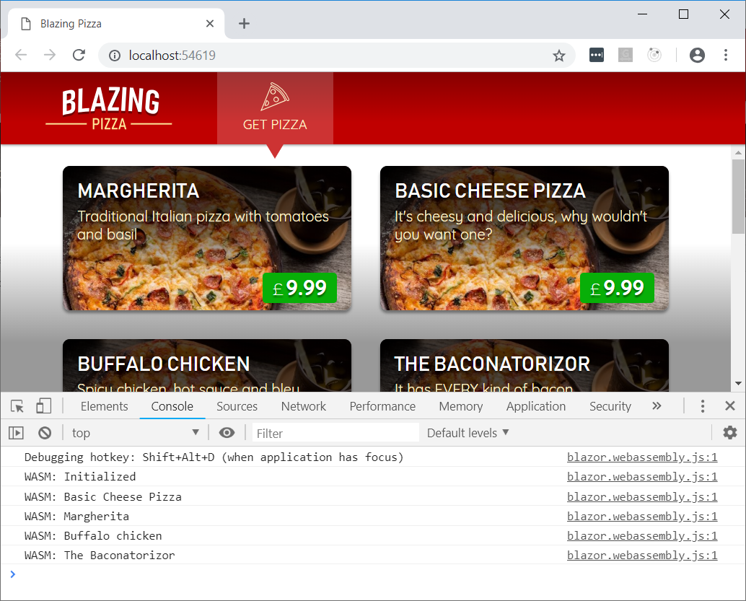](https://user-images.githubusercontent.com/1874516/51804286-ce965000-2256-11e9-87fc-a8770ccc70d8.png)

1. The @ symbol is used in Razor files to indicate the start of C# code. Surround the C# code with parentheses if needed to clarify where the C# code begins and ends.
2. Update the @code block in Index.razor to add some additional fields for tracking the pizza being customized and whether the pizza customization dialog is visible.

List<PizzaSpecial> specials;

Pizza configuringPizza;

bool showingConfigureDialog;

1. Add a ShowConfigurePizzaDialog method to the @code block for handling when a pizza special is clicked.

void ShowConfigurePizzaDialog(PizzaSpecial special)

{

configuringPizza = new Pizza()

{

Special = special,

SpecialId = special.Id,

Size = Pizza.DefaultSize,

Toppings = new List<PizzaTopping>(),

};

showingConfigureDialog = true;

}

1. Update the @onclick handler to call the ShowConfigurePizzaDialog method instead of Console.WriteLine.

<li @onclick="@(() => ShowConfigurePizzaDialog(special))" style="background-image: url('@special.ImageUrl')">

Task 2: Passing Component Parameters

1. Now we need to implement the pizza customization dialog so we can display it when the user selects a pizza. The pizza customization dialog will be a new component that lets you specify the size of your pizza and what toppings you want, shows the price, and lets you add the pizza to your order. Add a **ConfigurePizzaDialog.razor** file under the **Shared** directory. Since this component is not a separate page, it does not need the @page directive.

Important

**In Visual Studio, you can right-click the Shared directory in Solution Explorer, then choose Add -> New Item, then use the Razor Component item template.**

1. The ConfigurePizzaDialog should have a Pizza parameter that specifies the pizza being configured. Component parameters are defined by adding a writable property to the component decorated with the [Parameter] attribute. Add a @code block to the ConfigurePizzaDialog with the following Pizza parameter:

@code {

[Parameter] public Pizza Pizza { get; set; }

}

Important

**Component parameter values need to have a setter and be declared public because they get set by the framework. However, they should only be set by the framework as part of the rendering process. Do not write code that overwrites these parameter values from outside the component, because then your component's state will be out of sync with its render output.**

1. Add the following basic markup for the ConfigurePizzaDialog:

<div class="dialog-container">

<div class="dialog">

<div class="dialog-title">

<h2>@Pizza.Special.Name</h2>

@Pizza.Special.Description

</div>

<form class="dialog-body"></form>

<div class="dialog-buttons">

<button class="btn btn-secondary mr-auto">Cancel</button>

<span class="mr-center">

Price: <span class="price">@(Pizza.GetFormattedTotalPrice())</span>

</span>

<button class="btn btn-success ml-auto">Order ></button>

</div>

</div>

</div>

1. Update Pages/Index.razor to show the ConfigurePizzaDialog when a pizza special has been selected. The ConfigurePizzaDialog is styled to overlay the current page, so it doesn't really matter where you put this code block.

@if (showingConfigureDialog)

{

<ConfigurePizzaDialog Pizza="configuringPizza" />

}

1. Run the app and select a pizza special to see the skeleton of the ConfigurePizzaDialog.

[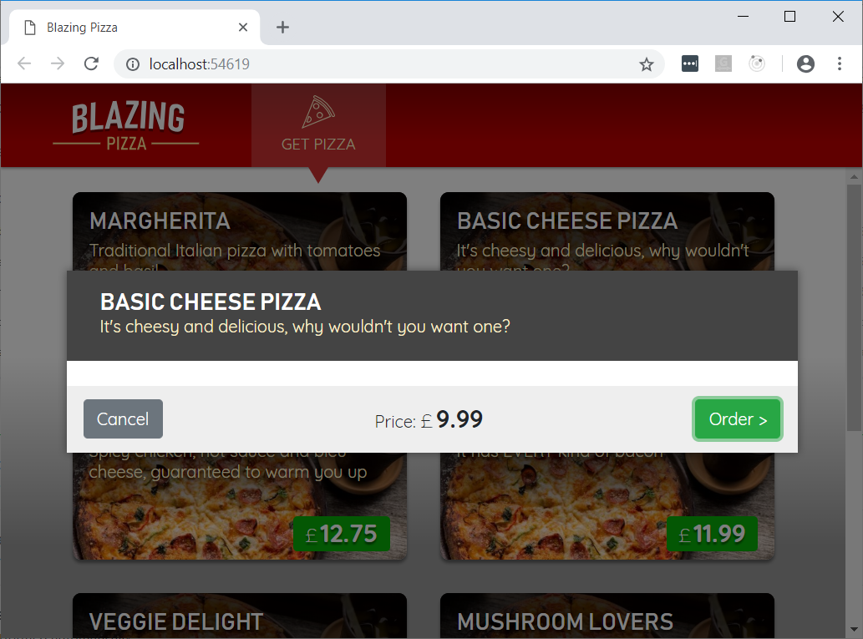](https://user-images.githubusercontent.com/1874516/51804297-e8d02e00-2256-11e9-85a6-da0becf7130d.png)

Unfortunately, at this point there is no functionality in place to close the dialog. We will add that shortly. Let us get to work on the dialog itself.

Task 3: Data Binding

1. Next you will allow the user to specify the size of their pizza. Add markup to the body of ConfigurePizzaDialog for a slider that lets the user specify the pizza size. This should replace the existing <form class="dialog-body"></form> element..

<form class="dialog-body">

<div>

<label>Size:</label>

<input type="range" min="@Pizza.MinimumSize" max="@Pizza.MaximumSize" step="1" />

<span class="size-label">

@(Pizza.Size)" (£@(Pizza.GetFormattedTotalPrice()))

</span>

</div>

</form>

1. Run the app and select a pizza special. Now the dialog shows a slider that can be used to change the pizza size. However it doesn't do anything right now if you use it.

[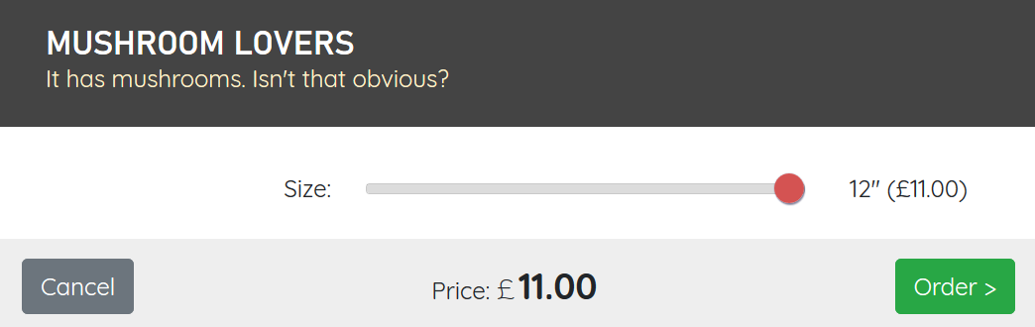](https://user-images.githubusercontent.com/1430011/57576985-eff40400-7421-11e9-9a1b-b22d96c06bcb.png)

1. We want to make it so the value of the Pizza.Size will reflect the value of the slider. When the dialog opens, the slider gets its value from Pizza.Size. Moving the slider should update the pizza size stored in Pizza.Size accordingly. This concept is called two-way binding.

If you wanted to implement two-way binding manually, you could do so by combining value and @onchange, as in the following code (which you don't actually need to put in your application, because there's an easier solution):

<input

type="range"

min="@Pizza.MinimumSize"

max="@Pizza.MaximumSize"

step="1"

value="@Pizza.Size"

@onchange="@((ChangeEventArgs e) => Pizza.Size = int.Parse((string) e.Value))" />

In Blazor you can use the @bind directive attribute to specify a two-way binding with this behavior. The equivalent markup using @bind looks like this:

<input type="range" min="@Pizza.MinimumSize" max="@Pizza.MaximumSize" step="1" @bind="@Pizza.Size" />

But if we use @bind with no further changes, the behavior isn't exactly what we want. Give it a try and see how it behaves. The update event only fires after the slider is released.

We would prefer to see updates as the slider is moved. Data binding in Blazor allows for this by letting you specify what event triggers a change using the syntax @bind:<eventname>. So, to bind using the oninput event instead do this:

<input type="range" min="@Pizza.MinimumSize" max="@Pizza.MaximumSize" step="1" @bind="@Pizza.Size" @bind:event="oninput" />

The pizza size should now update as you move the slider.

Task 4: Adding Additional Event Handlers

1. The user should also be able to select additional toppings on ConfigurePizzaDialog. Add a list property for storing the available toppings. Initialize the list of available toppings by making an HTTP GET request to the /toppings API.

@inject HttpClient HttpClient

<div class="dialog-container">

...

</div>

@code {

List<Topping> toppings;

[Parameter] public Pizza Pizza { get; set; }

protected async override Task OnInitializedAsync()

{

toppings = await HttpClient.GetJsonAsync<List<Topping>>("toppings");

}

}

1. Add the following markup in the dialog body for displaying a drop down list with the list of available toppings followed by the set of selected toppings. Put this inside the <form class="dialog-body">, below the existing <div>."

<div>

<label>Extra Toppings:</label>

@if (toppings == null)

{

<select class="custom-select" disabled>

<option>(loading...)</option>

</select>

}

else if (Pizza.Toppings.Count >= 6)

{

<div>(maximum reached)</div>

}

else

{

<select class="custom-select" @onchange="@ToppingSelected">

<option value="-1" disabled selected>(select)</option>

@for (var i = 0; i < toppings.Count; i++)

{

<option value="@i">@toppings[i].Name - (£@(toppings[i].GetFormattedPrice()))</option>

}

</select>

}

</div>

<div class="toppings">

@foreach (var topping in Pizza.Toppings)

{

<div class="topping">

@topping.Topping.Name

<span class="topping-price">@topping.Topping.GetFormattedPrice()</span>

<button type="button" class="delete-topping" @onclick="@(() => RemoveTopping(topping.Topping))">x</button>

</div>

}

</div>

1. Also add the following event handlers for topping selection and removal:

void ToppingSelected(ChangeEventArgs e)

{

if (int.TryParse((string)e.Value, out var index) && index >= 0)

{

AddTopping(toppings[index]);

}

}

void AddTopping(Topping topping)

{

if (Pizza.Toppings.Find(pt => pt.Topping == topping) == null)

{

Pizza.Toppings.Add(new PizzaTopping() { Topping = topping });

}

}

void RemoveTopping(Topping topping)

{

Pizza.Toppings.RemoveAll(pt => pt.Topping == topping);

}

You should now be able to add and remove toppings.

[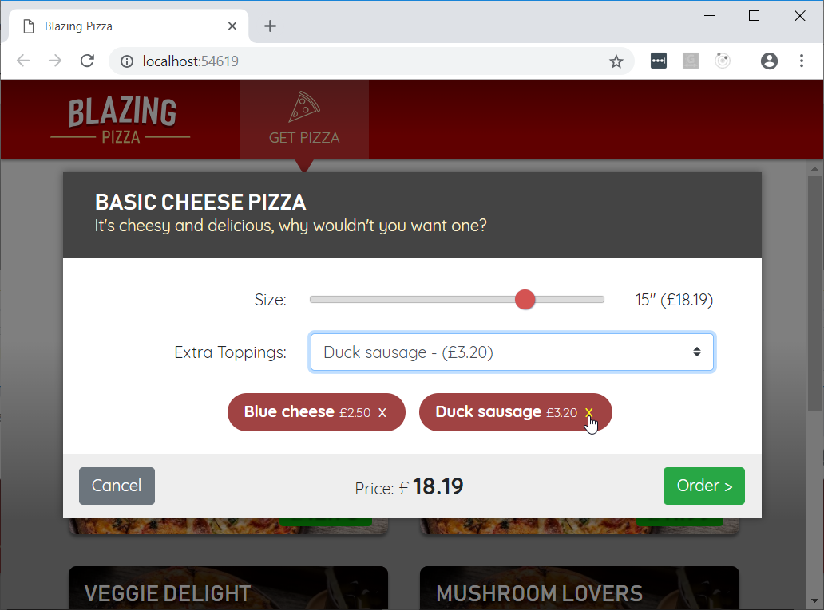](https://user-images.githubusercontent.com/1874516/51805012-f50cb900-225f-11e9-8642-4e6d34a48c3f.png)

Task 5: Component Events

1. The Cancel and Order buttons don't do anything yet. We need some way to communicate to the Index component when the user adds the pizza to their order or cancels. We can do that by defining component events. Component events are callback parameters that parent components can subscribe to. Add two parameters to the ConfigurePizzaDialog component: OnCancel and OnConfirm. Both parameters should be of type EventCallback.

[Parameter] public EventCallback OnCancel { get; set; }

[Parameter] public EventCallback OnConfirm { get; set; }

1. Add @onclick event handlers to the ConfigurePizzaDialog that trigger the OnCancel and OnConfirm events.

<div class="dialog-buttons">

<button class="btn btn-secondary mr-auto" @onclick="@OnCancel">Cancel</button>

<span class="mr-center">

Price: <span class="price">@(Pizza.GetFormattedTotalPrice())</span>

</span>

<button class="btn btn-success ml-auto" @onclick="@OnConfirm">Order ></button>

</div>

1. In the Index component add an event handler for the OnCancel event that hides the dialog and wires it up to the ConfigurePizzaDialog.

<ConfigurePizzaDialog Pizza="configuringPizza" OnCancel="CancelConfigurePizzaDialog" />

void CancelConfigurePizzaDialog()

{

configuringPizza = null;

showingConfigureDialog = false;

}

Now, what happens when you click the dialog cancel button is that Index.CancelConfigurePizzaDialog will execute, and then the Index component will render itself. Since showingConfigureDialog is now false the dialog will not be displayed.

Normally what happens when you trigger an event (like clicking the cancel button) is that the component that defined the event handler delegate will rerender. You could define events using any delegate type like Action or Func<string, Task>. Sometimes you want to use an event handler delegate that doesn't belong to a component - if you used a normal delegate type to define the event then nothing will be rendered or updated.

EventCallback is a special type that is known to the compiler that resolves some of these issues. It tells the compiler to dispatch the event to the component that contains the event handler logic. EventCallback has a few more tricks up its sleeve, but for now just remember that using EventCallback makes your component smart about dispatching events to the right place.

1. Run the app and verify that the dialog now disappears when the Cancel button is clicked.
2. When the OnConfirm event is fired, the customized pizza should be added to the user's order. Add an Order field to the Index component to track the user's order.

List<PizzaSpecial> specials;

Pizza configuringPizza;

bool showingConfigureDialog;

Order order = new Order();

In the Index component add an event handler for the OnConfirmevent that adds the configured pizza to the order and wire it up to the ConfigurePizzaDialog.

<ConfigurePizzaDialog

Pizza="configuringPizza"

OnCancel="CancelConfigurePizzaDialog"

OnConfirm="ConfirmConfigurePizzaDialog" />

void ConfirmConfigurePizzaDialog()

{

order.Pizzas.Add(configuringPizza);

configuringPizza = null;

showingConfigureDialog = false;

}

1. Run the app and verify the dialog now disappears when the Order button is clicked. We can't see yet that a pizza was added to the order because there's no UI that shows this information. We'll address that next.
2. Next we need to display the configured pizzas in the current order, calculate the total price, and provide a way to place the order.

Create a new ConfiguredPizzaItem component for displaying a configured pizza. It takes two parameters: the configured pizza, and an event for when the pizza was removed.

<div class="cart-item">

<a @onclick="@OnRemoved" class="delete-item">x</a>

<div class="title">@(Pizza.Size)" @Pizza.Special.Name</div>

<ul>

@foreach (var topping in Pizza.Toppings)

{

<li>+ @topping.Topping.Name</li>

}

</ul>

<div class="item-price">

@Pizza.GetFormattedTotalPrice()

</div>

</div>

@code {

[Parameter] public Pizza Pizza { get; set; }

[Parameter] public EventCallback OnRemoved { get; set; }

}

1. Add the following markup to the Index component just below the main div to add a right side pane for displaying the configured pizzas in the current order.

<div class="sidebar">

@if (order.Pizzas.Any())

{

<div class="order-contents">

<h2>Your order</h2>

@foreach (var configuredPizza in order.Pizzas)

{

<ConfiguredPizzaItem Pizza="configuredPizza" OnRemoved="@(() => RemoveConfiguredPizza(configuredPizza))" />

}

</div>

}

else

{

<div class="empty-cart">Choose a pizza<br>to get started</div>

}

<div class="order-total @(order.Pizzas.Any() ? "" : "hidden")">

Total:

<span class="total-price">@order.GetFormattedTotalPrice()</span>

<button class="btn btn-warning" disabled="@(order.Pizzas.Count == 0)" @onclick="@PlaceOrder">

Order >

</button>

</div>

</div>

1. Also add the following event handlers to the Index component for removing a configured pizza from the order and submitting the order.

void RemoveConfiguredPizza(Pizza pizza)

{

order.Pizzas.Remove(pizza);

}

async Task PlaceOrder()

{

await HttpClient.PostJsonAsync("orders", order);

order = new Order();

}

You should now be able to add and remove configured pizzas from the order and submit the order.

[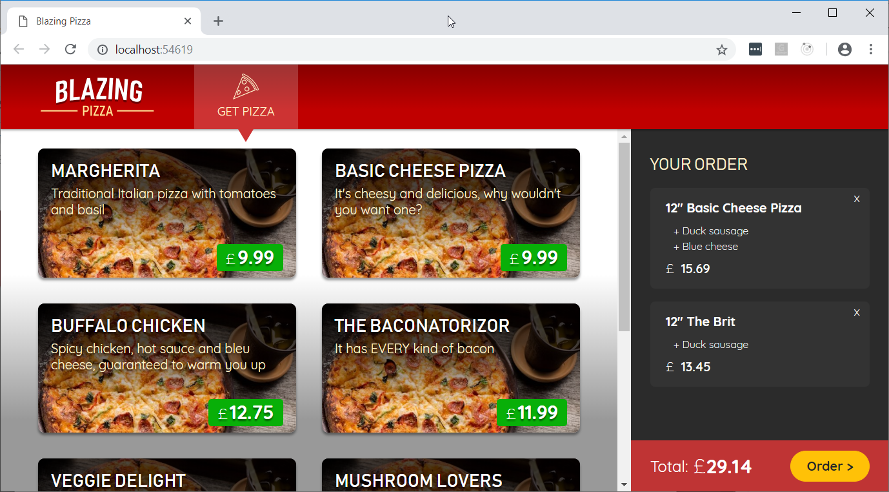](https://user-images.githubusercontent.com/1874516/51805192-59c91300-2262-11e9-9b6f-d8f2d606feda.png)

Even though the order was successfully added to the database, there's nothing in the UI yet that indicates this happened. That's what we'll address in the next session.

Exercise 4: Routing

#### Objectives

In this exercise, you will:

* Introduce routing to the application

#### Scenario

Your customers can order pizzas, but so far have no way to see the status of their orders. In this Exercise you'll implement a "My orders" page that lists multiple orders, plus an "Order details" view showing the contents and status of an individual order.

Task 1: Adding A Navigation Link

1. Start by opening the solution file **BlazingPizza.sln** located under **\Labs\Module 03 - Blazor\Routing\Begin**.
2. Open **Shared/MainLayout.razor**. As an experiment, let's try adding a new link element without using NavLink. Add a plain HTML <a> tag pointing to myorders:

<div class="top-bar">

(leave existing content in place)

<a href="myorders" class="nav-tab">

<img src="img/bike.svg" />

<div>My Orders</div>

</a>

</div>

Important

**Notice how the URL we are linking to does not start with a /. If you linked to /myorders, it would appear to work the same, but if you ever wanted to deploy the app to a non-root URL the link would break. The <base href="/"> tag in index.html specifies the prefix for all non-slash-prefixed URLs in the app, regardless of which component renders them.**

1. If you run the app now, you'll see the link(MY ORDERS), styled as expected:

[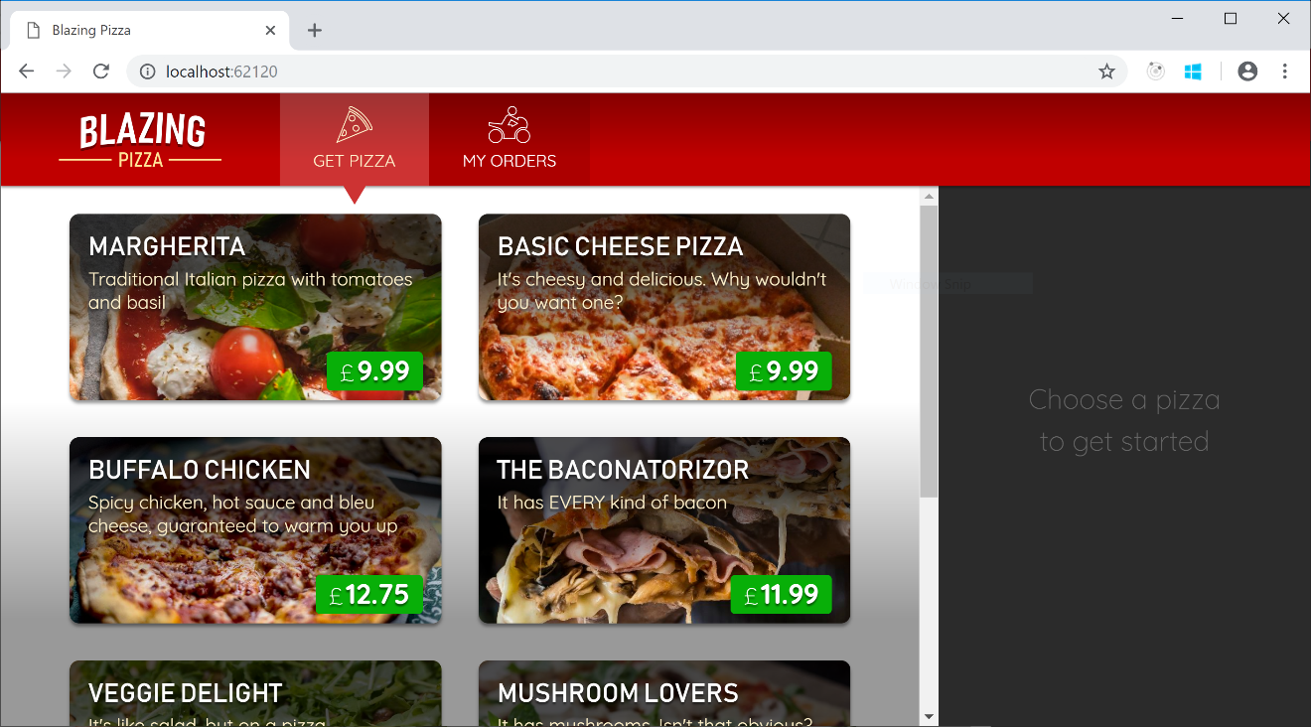](https://user-images.githubusercontent.com/1101362/51804403-60528d00-2258-11e9-8d2b-ab00d33c74cb.png)

This shows it's not strictly necessary to use <NavLink>. We'll see the reason to use it momentarily.

1. If you click "My Orders", you'll end up on a page that says "Page not found". Obviously this is because you haven't yet added anything that matches the URL myorders. But if you're watching really carefully, you might notice that on this occasion it's not just doing client-side (SPA-style) navigation, but instead is doing a full-page reload.   
   What's really happening is this:
   1. You click on the link to myorders
   2. Blazor, running on the client, tries to match this to a client-side component based on @page directive attributes.
   3. However, no match is found, so Blazor falls back on a full-page load navigation in case the URL is meant to be handled by server-side code.
   4. However, the server doesn't have anything that matches this either, so it falls back on rendering the client-side Blazor application.
   5. This time, Blazor sees that nothing matches on either client or server, so it falls back on rendering the NotFound block from your App.razor component.

If you want to, try changing the content in the NotFound block in App.razor to see how you can customize this message.   
As you can guess, we will make the link actually work by adding a component to match this route. Create a file in the Pages folder called MyOrders.razor, with the following content:

@page "/myorders"

<div class="main">

My orders will go here

</div>

1. Now when you run the app, you'll be able to visit this page. Also notice that this time, no full-page load occurs when you navigate, because the URL is matched entirely within the client-side SPA. As such, navigation is instantaneous.

[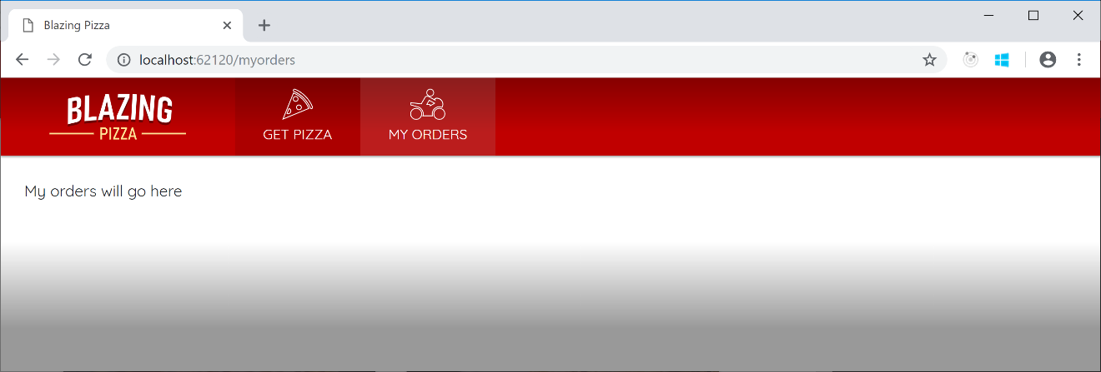](https://user-images.githubusercontent.com/1101362/51804512-c855a300-2259-11e9-8770-b4b8c318ba9d.png)

1. Look closely at the top bar. Notice that when you're on "My orders", the link isn't highlighted in yellow. How can we highlight links when the user is on them? By using a <NavLink> instead of a plain <a> tag. The only thing a NavLink does is toggle its own active CSS class depending on whether it matches the current navigation state. Replace the <a> tag you just added in MainLayout with the following (which is identical apart from the tag name):

<NavLink href="myorders" class="nav-tab">

<img src="img/bike.svg" />

<div>My Orders</div>

</NavLink>

1. Now you'll see the links are correctly highlighted according to navigation state:

[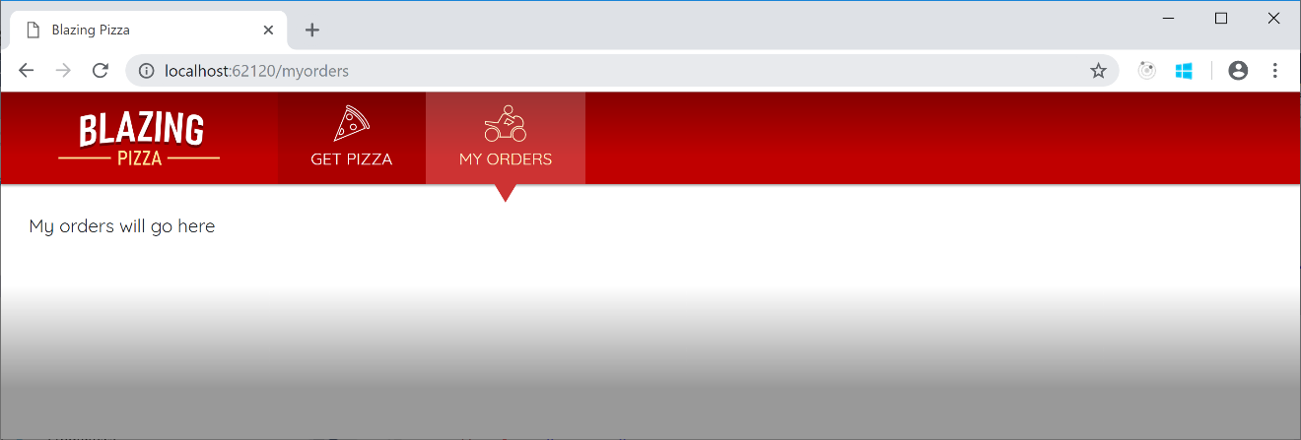](https://user-images.githubusercontent.com/1101362/51804583-ca6c3180-225a-11e9-86cb-58a5a469e3f7.png)

1. Switch back to the MyOrders component code. Once again we're going to inject an HttpClient so that we can query the backend for data. Add the following under the @page directive line:

@inject HttpClient HttpClient

1. Then add a @code block that makes an asynchronous request for the data we need:

@code {

List<OrderWithStatus> ordersWithStatus;

protected override async Task OnParametersSetAsync()

{

ordersWithStatus = await HttpClient.GetJsonAsync<List<OrderWithStatus>>("orders");

}

}

1. Let's make the UI display different output in three different cases:

* While we're waiting for the data to load
* If it turns out that the user has never placed any orders
* If the user has placed one or more orders

It's simple to express this using @if/else blocks in Razor code. Update the markup inside your component as follows:

<div class="main">

@if (ordersWithStatus == null)

{

<text>Loading...</text>

}

else if (ordersWithStatus.Count == 0)

{

<h2>No orders placed</h2>

<a class="btn btn-success" href="">Order some pizza</a>

}

else

{

<text>TODO: show orders</text>

}

</div>

Perhaps some parts of this code aren't obvious, so let's point out a few things:

* <text> is not an HTML element at all. Nor is it a component. Once the MyOrderscomponent is compiled, the <text> tag won't exist in the result at all.
* If <a href=""> (with an empty string for href) surprises you, remember that the browser will prefix the <base href="/"> value to all non-slash-prefixed URLs. So, an empty string is the correct way to link to the client app's root URL.
* The asynchronous flow we've implemented above means the component will render twice: once before the data has loaded (displaying "Loading.."), and then once afterwards (displaying one of the other two outputs).
* If you want to reset your database to see the "no orders" case, simply delete pizza.db from the Server project and reload the page in your browser.

1. Now we have all the data we need, we can use Razor syntax to render an HTML grid. Now we have all the data we need, we can use Razor syntax to render an HTML grid. Replace the <text>TODO: show orders</text> code with the following. It looks like a lot of code, but there's nothing special here. It simply uses a @foreach to iterate over the ordersWithStatus and outputs a <div> for each one. The net result is as follows:

<div class="list-group orders-list">

@foreach (var item in ordersWithStatus)

{

<div class="list-group-item">

<div class="col">

<h5>@item.Order.CreatedTime.ToLongDateString()</h5>

Items:

<strong>@item.Order.Pizzas.Count()</strong>;

Total price:

<strong>£@item.Order.GetFormattedTotalPrice()</strong>

</div>

<div class="col">

Status: <strong>@item.StatusText</strong>

</div>

<div class="col flex-grow-0">

<a href="myorders/@item.Order.OrderId" class="btn btn-success">

Track &gt;

</a>

</div>

</div>

}

</div>

[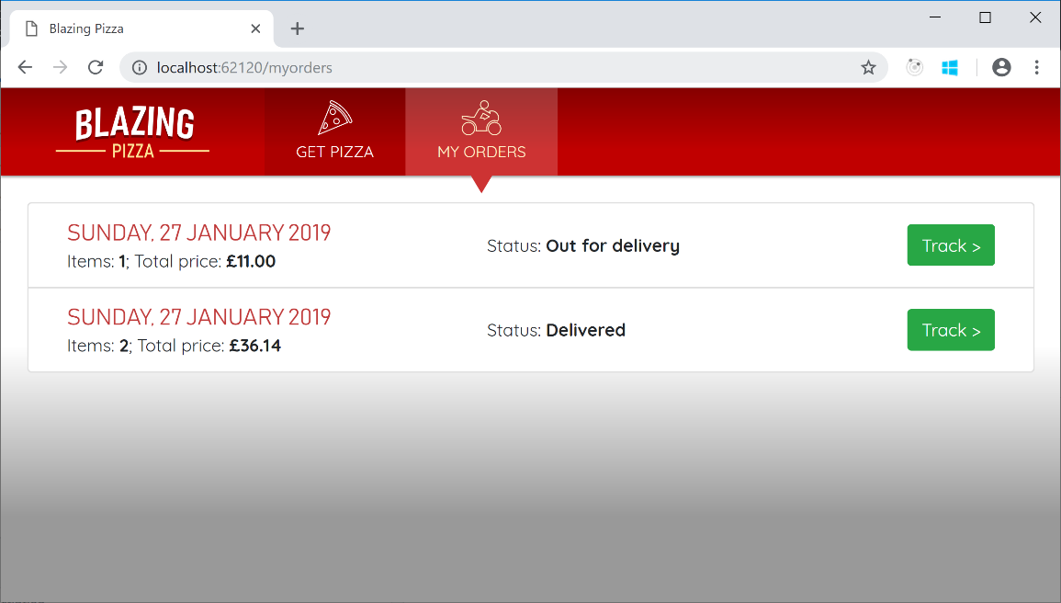](https://user-images.githubusercontent.com/1101362/51804902-300ded00-225e-11e9-85b7-6aa2ac764123.png)

1. If you click on the "Track" link buttons next to an order, the browser will attempt to navigation to myorders/<id> (e.g., http://example.com/myorders/37). Currently this will result in a "Page not found" message because no component matches this route.

Once again we'll add a component to handle this. In the Pages directory, create a file called OrderDetails.razor, containing:

@page "/myorders/{orderId:int}"

<div class="main">

TODO: Show details for order @OrderId

</div>

@code {

[Parameter] public int OrderId { get; set; }

}

This code illustrates how components can receive parameters from the router by declaring them as tokens in the @page directive. If you want to receive a string, the syntax is simply {parameterName}, which matches a [Parameter] name case-insensitively. If you want to receive a numeric value, the syntax is {parameterName:int}, as in the example above. The :int is an example of a route constraint. Other route constraints are supported too.

[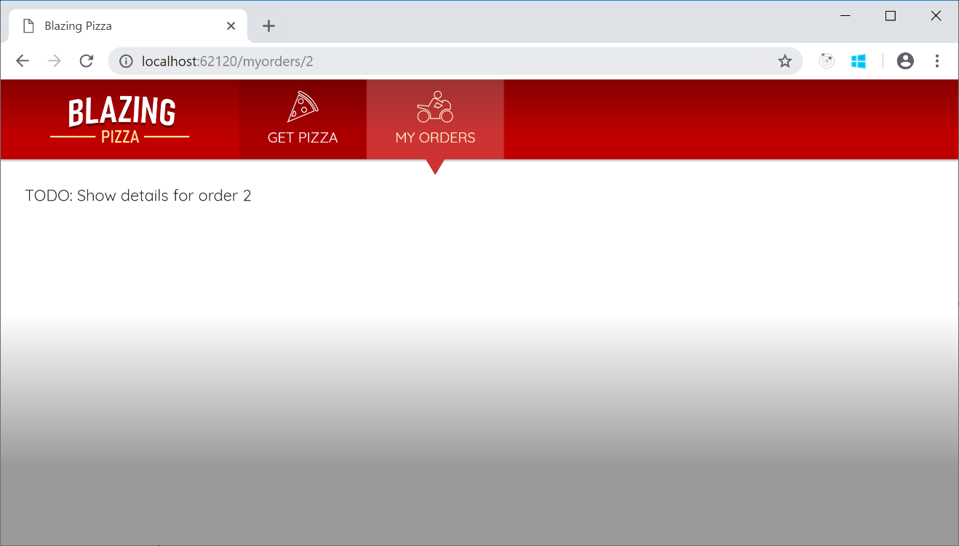](https://user-images.githubusercontent.com/1101362/51805000-cc84bf00-225f-11e9-824b-348561ccc2fa.png)

If you're wondering how routing actually works, let's go through it step-by-step.

* When the app first starts up, code in Startup.cs tells the framework to render App as the root component.
* The App component (in App.razor) contains a <Router>. Router is a built-in component that interacts with the browser's client-side navigation APIs. It registers a navigation event handler that gets notification whenever the user clicks on a link.
* Whenever the user clicks a link, code in Router checks whether the destination URL is within the same SPA (i.e., whether it's under the <base href> value, and it matches some component's declared routes). If it's not, traditional full-page navigation occurs as usual. But if the URL is within the SPA, Router will handle it.
* Router handles it by looking for a component with a compatible @page URL pattern. Each {parameter} token needs to have a value, and the value has to be compatible with any constraints such as :int.
  + If there is a matching component, that's what the Router will render. This is how all the pages in your application have been rendering all along.
  + If there's no matching component, the router tries a full-page load in case it matches something on the server.
  + If the server chooses to re-render the client-side Blazor app (which is also what happens if a visitor is initially arriving at this URL and the server thinks it may be a client-side route), then Blazor concludes the nothing matches on either server or client, so it displays whatever NotFound content is configured.

1. The OrderDetails logic will be quite different from MyOrders. Instead of simply fetching the data once when the component is instantiated, we'll poll the server every few seconds for updated data. This will make it possible to show the order status in (nearly) real-time, and later, to display the delivery driver's location on a moving map. What's more, we'll also account for the possibility of OrderId being invalid. This might happen if:

* No such order exists
* Or later, when we've implemented authentication, if the order is for a different user and you're not allowed to see it

Before we can implement the polling, we'll need to add the following directives at the top of OrderDetails.razor, typically directly under the @page directive:

@using System.Threading

@inject HttpClient HttpClient

You've already seen @inject used with HttpClient, so you know what that is for. Plus, you'll recognize @using from the equivalent in regular .cs files, so this shouldn't be much of a mystery either. Unfortunately, Visual Studio does not yet add @using directives automatically in Razor files, so you do have to write them in yourself when needed.

Now you can implement the polling. Update your @code block as follows:

@code {

[Parameter] public int OrderId { get; set; }

OrderWithStatus orderWithStatus;

bool invalidOrder;

CancellationTokenSource pollingCancellationToken;

protected override void OnParametersSet()

{

// If we were already polling for a different order, stop doing so

pollingCancellationToken?.Cancel();

// Start a new poll loop

PollForUpdates();

}

private async void PollForUpdates()

{

pollingCancellationToken = new CancellationTokenSource();

while (!pollingCancellationToken.IsCancellationRequested)

{

try

{

invalidOrder = false;

orderWithStatus = await HttpClient.GetJsonAsync<OrderWithStatus>($"orders/{OrderId}");

}

catch (Exception ex)

{

invalidOrder = true;

pollingCancellationToken.Cancel();

Console.Error.WriteLine(ex);

}

StateHasChanged();

await Task.Delay(4000);

}

}

}

The code is a bit intricate, so be sure to go through it carefully and be sure to understand each aspect of it. Here are some notes:

* This uses OnParametersSet instead of OnInitialized or OnInitializedAsync. OnParametersSet is another component lifecycle method, and it fires when the component is first instantiated *and* any time its parameters change value. If the user clicks a link directly from myorders/2 to myorders/3, the framework will retain the OrderDetails instance and simply update its OrderId parameter in place.
  + As it happens, we haven't provided any links from one "my orders" screen to another, so the scenario never occurs in this application, but it's still the right lifecycle method to use in case we change the navigation rules in the future.
* We're using an async void method to represent the polling. This method runs for arbitrarily long, even while other methods run. async void methods have no way to report exceptions upstream to callers (because typically the callers have already finished), so it's important to use try/catch and do something meaningful with any exceptions that may occur.
* We're using CancellationTokenSource as a way of signalling when the polling should stop. Currently it only stops if there's an exception, but we'll add another stopping condition later.
* We need to call StateHasChanged to tell Blazor that the component's data has (possibly) changed. The framework will then re-render the component. There's no way that the framework could know when to re-render your component otherwise, because it doesn't know about your polling logic.

1. OK, so we're getting the order details, and we're even polling and updating that data every few seconds. But we're still not rendering it in the UI. Let's fix that. Update your <div class="main"> as follows:

<div class="main">

@if (invalidOrder)

{

<h2>Nope</h2>

<p>Sorry, this order could not be loaded.</p>

}

else if (orderWithStatus == null)

{

<text>Loading...</text>

}

else

{

<div class="track-order">

<div class="track-order-title">

<h2>

Order placed @orderWithStatus.Order.CreatedTime.ToLongDateString()

</h2>

<p class="ml-auto mb-0">

Status: <strong>@orderWithStatus.StatusText</strong>

</p>

</div>

<div class="track-order-body">

TODO: show more details

</div>

</div>

}

</div>

This accounts for the three main states of the component:

1. If the OrderId value is invalid (i.e., the server reported an error when we tried to retrieve the data)
2. If we haven't yet loaded the data
3. If we have got some data to show

[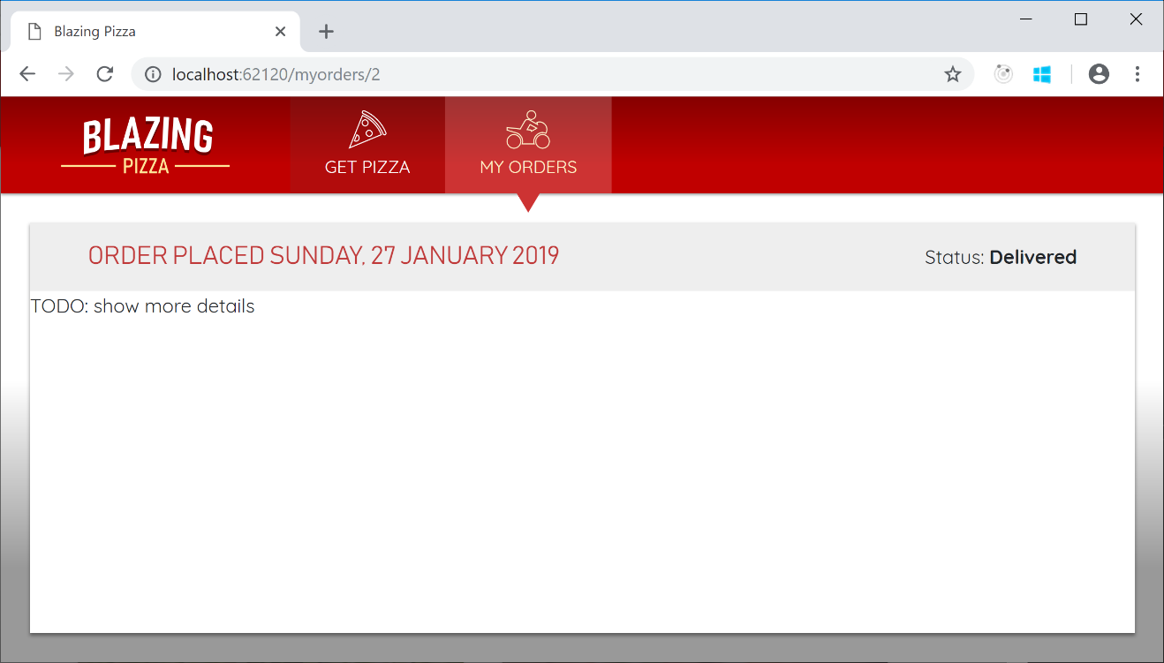](https://user-images.githubusercontent.com/1101362/51805193-5c2b6d00-2262-11e9-98a6-c5a8ec4bb54f.png)

The last bit of UI we want to add is the actual contents of the order. To do this, we'll create another reusable component.

1. Create a new file, OrderReview.razor inside the Shared directory, and have it receive an Order and render its contents as follows:

@foreach (var pizza in Order.Pizzas)

{

<p>

<strong>

@(pizza.Size)"

@pizza.Special.Name

(£@pizza.GetFormattedTotalPrice())

</strong>

</p>

<ul>

@foreach (var topping in pizza.Toppings)

{

<li>+ @topping.Topping.Name</li>

}

</ul>

}

<p>

<strong>

Total price:

£@Order.GetFormattedTotalPrice()

</strong>

</p>

@code {

[Parameter] public Order Order { get; set; }

}

1. Finally, back in OrderDetails.razor, replace text TODO: show more details with your new OrderReview component:

<div class="track-order-body">

<div class="track-order-details">

<OrderReview Order="@orderWithStatus.Order" />

</div>

</div>

(Don't forget to add the extra div with CSS class track-order-details, as this is necessary for correct styling.)

1. Finally, you have a functional order details display!

[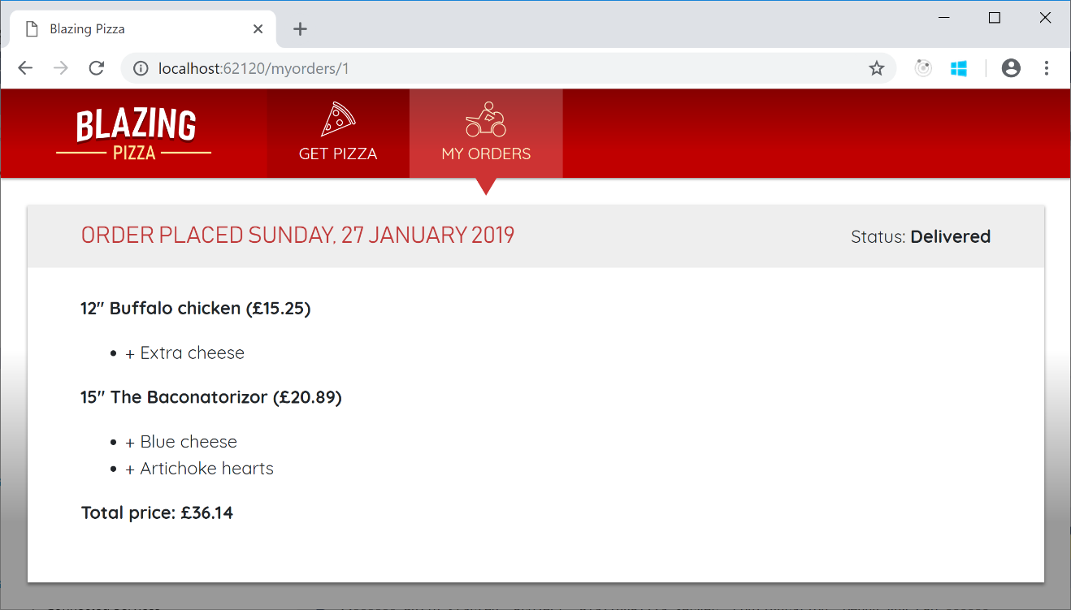](https://user-images.githubusercontent.com/1101362/51805236-ea9fee80-2262-11e9-814b-8f92f5dbe0de.png)

The backend server will update the order status to simulate an actual dispatch and delivery process. To see this in action, try placing a new order, then immediately view its details.

Initially, the order status will be *Preparing*, then after 10-15 seconds will change to *Out for delivery*, then 60 seconds later will change to *Delivered*. Because OrderDetails polls for updates, the UI will update without the user having to refresh the page.

1. If you deployed your app to production right now, bad things would happen. The OrderDetails logic starts a polling process, but doesn't end it. If the user navigated through hundreds of different orders (thereby creating hundreds of different OrderDetails instances), then there would be hundreds of polling processes left running concurrently, even though all except the last were pointless because no UI was displaying their results.

You can actually observe this chaos yourself as follows:

* Navigate to "my orders"
* Click "Track" on any order to get to its details
* Click "Back" to return to "my orders"
* Repeat steps 2 and 3 a lot of times (e.g., 20 times)
* Now, open your browser's debugging tools and look in the network tab. You should see 20 or more HTTP requests being issued every few seconds, because there are 20 or more concurrent polling processes.

This is wasteful of client-side memory and CPU time, network bandwidth, and server resources.

To fix this, we need to make OrderDetails stop the polling once it gets removed from the display. This is simply a matter of using the IDisposable interface.

In OrderDetails.razor, add the following directive at the top of the file, underneath the other directives:

@implements IDisposable

Now if you try to compile the application, the compiler will complain:

error CS0535: 'OrderDetails' does not implement interface member 'IDisposable.Dispose()'

Resolve this by adding the following method inside the @code block:

void IDisposable.Dispose()

{

pollingCancellationToken?.Cancel();

}

The framework calls Dispose automatically when any given component instance is torn down and removed from the UI.

Once you've put in this fix, you can try again to start lots of concurrent polling processes, and you'll see they no longer keep running after the component is gone. Now, the only component that continues to poll is the one that remains on the screen.

1. Right now, once users place an order, the Index component simply resets its state and their order appears to vanish without a trace. This is not very reassuring for users. We know the order is in the database, but users don't know that. It would be nice if, once the order is placed, you navigated to the details display for that order automatically. This is quite easy to do. Switch back to your Index component code. Add the following directive at the top:

@inject NavigationManager NavigationManager

The NavigationManager lets you interact with URIs and navigation state. It has methods to get the current URL, to navigate to a different one, and more.

To use this, update the PlaceOrder code so it calls NavigationManager.NavigateTo:

async Task PlaceOrder()

{

var newOrderId = await HttpClient.PostJsonAsync<int>("orders", order);

order = new Order();

NavigationManager.NavigateTo($"myorders/{newOrderId}");

}

Now as soon as the server accepts the order, the browser will switch to the "order details" display and begin polling for updates.

Exercise 5: State Management

#### Objectives

In this exercise, you will:

* Learn how to manage state across components

#### Scenario

In this exercise we'll revisit some of the code we've already written and try to make it nicer. We'll also talk more about eventing and how events cause the UI to update.

Task 1: Adding A Navigation Link

1. Start by opening the solution file **BlazingPizza.sln** located under **\Labs\Module 03 - Blazor\State Management\Begin**.
2. You might have noticed this already, but our application has a bug! Since we're storing the list of pizzas in the current order on the Index component, the user's state can be lost if the user leaves the Index page. To see this in action, add a pizza to the current order (don't place the order yet) - then navigate to the MyOrders page and back to Index. When you get back, you'll notice the order is empty!

We're going to fix this bug by introducing something we've dubbed the AppState pattern. The basics are that you want to add an object to the DI container that you will use to coordinate state between related components. Because the AppState object is managed by the DI container, it can outlive the components and hold on to state even when the UI is changing a lot. Another benefit of the AppState pattern is that it leads to greater separation between presentation (components) and business logic.

1. Create a new class called OrderState in the Client Project root directory - and register it as a scoped service in the DI container. Much like an ASP.NET Core method, a Blazor application has a Startup class and a ConfigureServices method. Add the service in Startup.cs.

public void ConfigureServices(IServiceCollection services)

{

services.AddScoped<OrderState>();

}

note: the reason why we choose scoped over singleton is for symmetry with a server-side-components application. Singleton usually means for all users, where as scoped means for the current unit-of-work.

1. Now that this type is registered in DI, we can @inject it into the Index page.

@page "/"

@inject HttpClient HttpClient

@inject OrderState OrderState

@inject NavigationManager NavigationManager

Recall that @inject is a convenient shorthand to both retrieve something from DI by type, and define a property of that type.

You can test this now by running the app again. If you try to inject something that isn't found in the DI container, then it will throw an exception and the Index will fail to come up.

You can test this now by running the app again. If you try to inject something that isn't found in the DI container, then it will throw an exception and the Index will fail to come up.

1. Now, let's add properties and methods to this class that will represent and manipulate the state of an Order and a Pizza.

Move the configuringPizza, showingConfigureDialog and order to be properties on the OrderState class. I like to make them private set so they can only be manipulated via methods on OrderState.

public class OrderState

{

public bool ShowingConfigureDialog { get; private set; }

public Pizza ConfiguringPizza { get; private set; }

public Order Order { get; private set; } = new Order();

}

1. Now let's move some of the methods from the Index to OrderState. We won't move PlaceOrder into OrderState because that triggers a navigation, so instead we'll just add a ResetOrder method.

public void ShowConfigurePizzaDialog(PizzaSpecial special)

{

ConfiguringPizza = new Pizza()

{

Special = special,

SpecialId = special.Id,

Size = Pizza.DefaultSize,

Toppings = new List<PizzaTopping>(),

};

ShowingConfigureDialog = true;

}

public void CancelConfigurePizzaDialog()

{

ConfiguringPizza = null;

ShowingConfigureDialog = false;

}

public void ConfirmConfigurePizzaDialog()

{

Order.Pizzas.Add(ConfiguringPizza);

ConfiguringPizza = null;

ShowingConfigureDialog = false;

}

public void ResetOrder()

{

Order = new Order();

}

public void RemoveConfiguredPizza(Pizza pizza)

{

Order.Pizzas.Remove(pizza);

}

Remember to remove the corresponding methods from Index.razor. You must also remember to remove the order, configuringPizza, and showingConfigureDialog fields entirely from Index.razor, since you'll be getting the state data from the injected OrderState.

1. At this point it should be possible to get the Index component compiling again by updating references to refer to various bits attached to OrderState. For example, the remaining PlaceOrder method in Index.razor may look something like this:

async Task PlaceOrder()

{

var newOrderId = await HttpClient.PostJsonAsync<int>("orders", OrderState.Order);

OrderState.ResetOrder();

NavigationManager.NavigateTo($"myorders/{newOrderId}");

}

Feel free to create convenience properties for things like OrderState.Order or OrderState.Order.Pizzas if it feels better to you that way. Try this out and verify that everything still works. In particular, verify that you've fixed the original bug: you can now add some pizzas, navigate to "My orders", navigate back, and your order has no longer been lost.

This is a good opportunity to explore how state changes and rendering work in Blazor, and how EventCallback solves some common problems. The detail of what are happening now became more complicated now that OrderState involved. EventCallback tells Blazor to dispatch the event notification (and rendering) to the component that defined the event handler. If the event handler is not defined by a component (OrderState) then it will substitute the component that *hooked up* the event handler (Index).

Exercise 6: Validation

#### Objectives

In this exercise, you will:

* Introduce Server Side Validation
* Introduce Client Validation

#### Scenario

If you take a look at the Order class in BlazingPizza.Shared, you might notice that it holds a DeliveryAddress property of type Address. However, nothing in the pizza ordering flow yet populates this data, so all your orders just have a blank delivery address.

It's time to fix this by adding a "checkout" screen that requires customers to enter a valid address.

Task 1: Inserting checkout into the flow

1. Start by opening the solution file **BlazingPizza.sln** located under **\Labs\Module 03 - Blazor\Validation\Begin**.
2. Start by adding a new page component, Checkout.razor, with a @page directive matching the URL /checkout. For the initial markup, let's display the details of the order using your OrderReview component:

<div class="main">

<div class="checkout-cols">

<div class="checkout-order-details">

<h4>Review order</h4>

<OrderReview Order="OrderState.Order" />

</div>

</div>

<button class="checkout-button btn btn-warning" @onclick="PlaceOrder">

Place order

</button>

</div>

1. To implement PlaceOrder, copy the method with that name from Index.razor into Checkout.razor:

@code {

async Task PlaceOrder()

{

var newOrderId = await HttpClient.PostJsonAsync<int>("orders", OrderState.Order);

OrderState.ResetOrder();

NavigationManager.NavigateTo($"myorders/{newOrderId}");

}

}

1. As usual, you'll need to @inject values for OrderState, HttpClient, and NavigationManager so that it can compile, just like you did in Index.razor.

Next, let's bring customers here when they try to submit orders. Back in Index.razor, make sure you've deleted the PlaceOrder method, and then change the order submission button into a regular HTML link to the /checkout URL, i.e.:

<a href="checkout" class="btn btn-warning" disabled="@(OrderState.Order.Pizzas.Count == 0)">

Order >

</a>

1. Now, when you run the app, you should be able to reach the checkout page by clicking the Order button, and from there can click Place order to confirm it.

[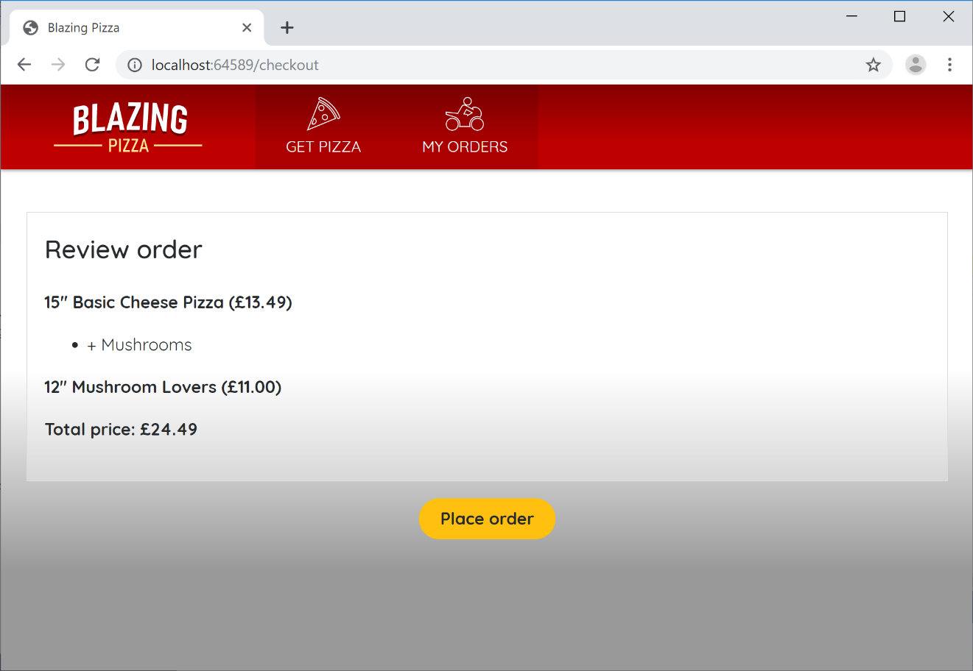](https://user-images.githubusercontent.com/1101362/59218134-674ebc00-8bb7-11e9-97d6-0c9985f10acf.png)

1. We've now got a good place to put some UI for entering a delivery address. As usual, let's factor this out into a reusable component. You never know when you're going to be asking for addresses in other places.

Create a new component in the BlazingPizza.Client project's Shared folder called AddressEditor.razor. It's going to be a general way to edit Address instances, so have it receive a parameter of this type:

@code {

[Parameter] public Address Address { get; set; }

}

1. The markup here is going to be a bit tedious, so you probably want to copy and paste this. We'll need input elements for each of the properties on an Address:

<div class="form-field">

<label>Name:</label>

<div>

<input @bind="Address.Name" />

</div>

</div>

<div class="form-field">

<label>Line 1:</label>

<div>

<input @bind="Address.Line1" />

</div>

</div>

<div class="form-field">

<label>Line 2:</label>

<div>

<input @bind="Address.Line2" />

</div>

</div>

<div class="form-field">

<label>City:</label>

<div>

<input @bind="Address.City" />

</div>

</div>

<div class="form-field">

<label>Region:</label>

<div>

<input @bind="Address.Region" />

</div>

</div>

<div class="form-field">

<label>Postal code:</label>

<div>

<input @bind="Address.PostalCode" />

</div>

</div>

@code {

[Parameter] public Address Address { get; set; }

}

1. Finally, you can actually use your AddressEditor inside the Checkout.razor component:

<div class="checkout-cols">

<div class="checkout-order-details">

... leave this div unchanged ...

</div>

<div class="checkout-delivery-address">

<h4>Deliver to...</h4>

<AddressEditor Address="@OrderState.Order.DeliveryAddress" />

</div>

</div>

1. Your checkout screen now asks for a delivery address:

[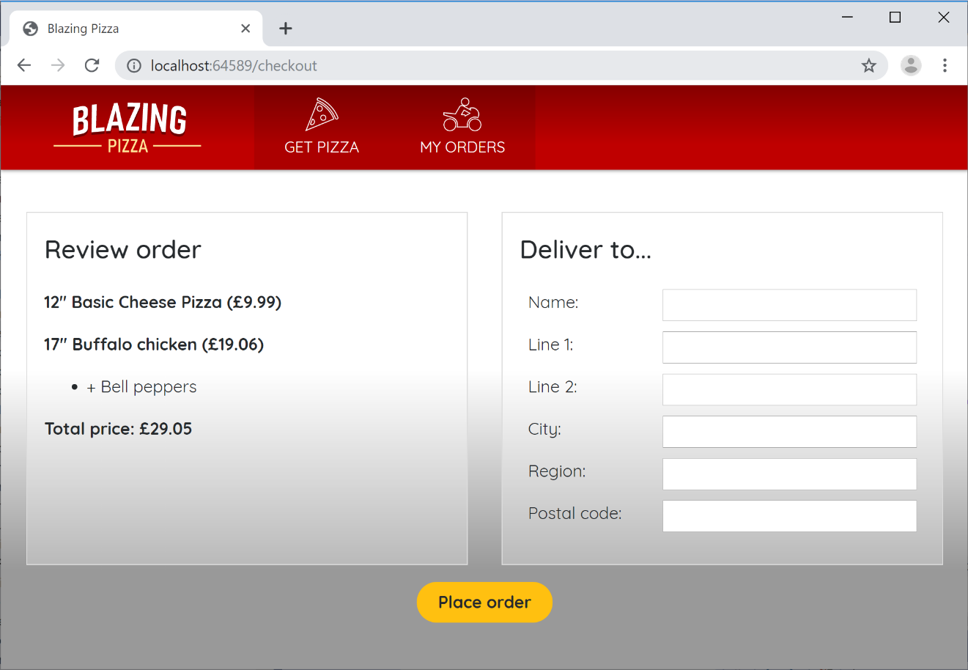](https://user-images.githubusercontent.com/1101362/59219467-76833900-8bba-11e9-960b-67aec2e2f8c7.png)

If you submit an order now, any address data that you entered will actually be saved in the database with the order, because it's all part of the Order object that gets serialized and sent to the server.

If you're really keen to verify the data gets saved, consider downloading a tool such as [DB Browser for SQLite](https://sqlitebrowser.org/) to inspect the contents of your pizza.db file. But you don't strictly need to do this.

Alternatively, set a breakpoint inside BlazingPizza.Server's OrderController.PlaceOrder method, and use the debugger to inspect the incoming Order object. Here you should be able to see the backend server receive the address data you typed in.

Task 2: Adding Server-side Validation

1. As yet, customers can still leave the "delivery address" fields blank and merrily order a pizza to be delivered nowhere in particular. When it comes to validation, it's normal to implement rules both on the server and on the client:

* Client-side validation is a courtesy to your users. It can provide instant feedback while they are editing a form. However, it can easily be bypassed by anyone with a basic knowledge of the browser dev tools.
* Server-side validation is where the real enforcement is.

As such it's usually best to start by implementing server-side validation, so you know your app is robust no matter what happens client-side. If you go and look at OrdersController.cs in the BlazingPizza.Server project, you'll see that this API endpoint is decorated with the [ApiController] attribute:

[Route("orders")]

[ApiController]

public class OrdersController : Controller

{

// ...

}

[ApiController] adds various server-side conventions, including enforcement of DataAnnotations validation rules. So all we need to do is put some DataAnnotations validation rules onto the model classes.

1. Open Address.cs from the BlazingPizza.Shared project, and put a [Required] attribute onto each of the properties except for Id (which is autogenerated, because it's the primary key) and Line2, since not all addresses need a second line. You can also place some [MaxLength] attributes if you wish, or any other DataAnnotations rules:

using System.ComponentModel.DataAnnotations;

namespace BlazingPizza

{

public class Address

{

public int Id { get; set; }

[Required, MaxLength(100)]

public string Name { get; set; }

[Required, MaxLength(100)]

public string Line1 { get; set; }

[MaxLength(100)]

public string Line2 { get; set; }

[Required, MaxLength(50)]

public string City { get; set; }

[Required, MaxLength(20)]

public string Region { get; set; }

[Required, MaxLength(20)]

public string PostalCode { get; set; }

}

}

1. Now, recompile and run your application, and you should be able to observe the validation rules being enforced on the server. If you try to submit an order with a blank delivery address, then the server will reject the request and you'll see an HTTP 400 ("Bad Request") error in the browser's *Network* tab:

[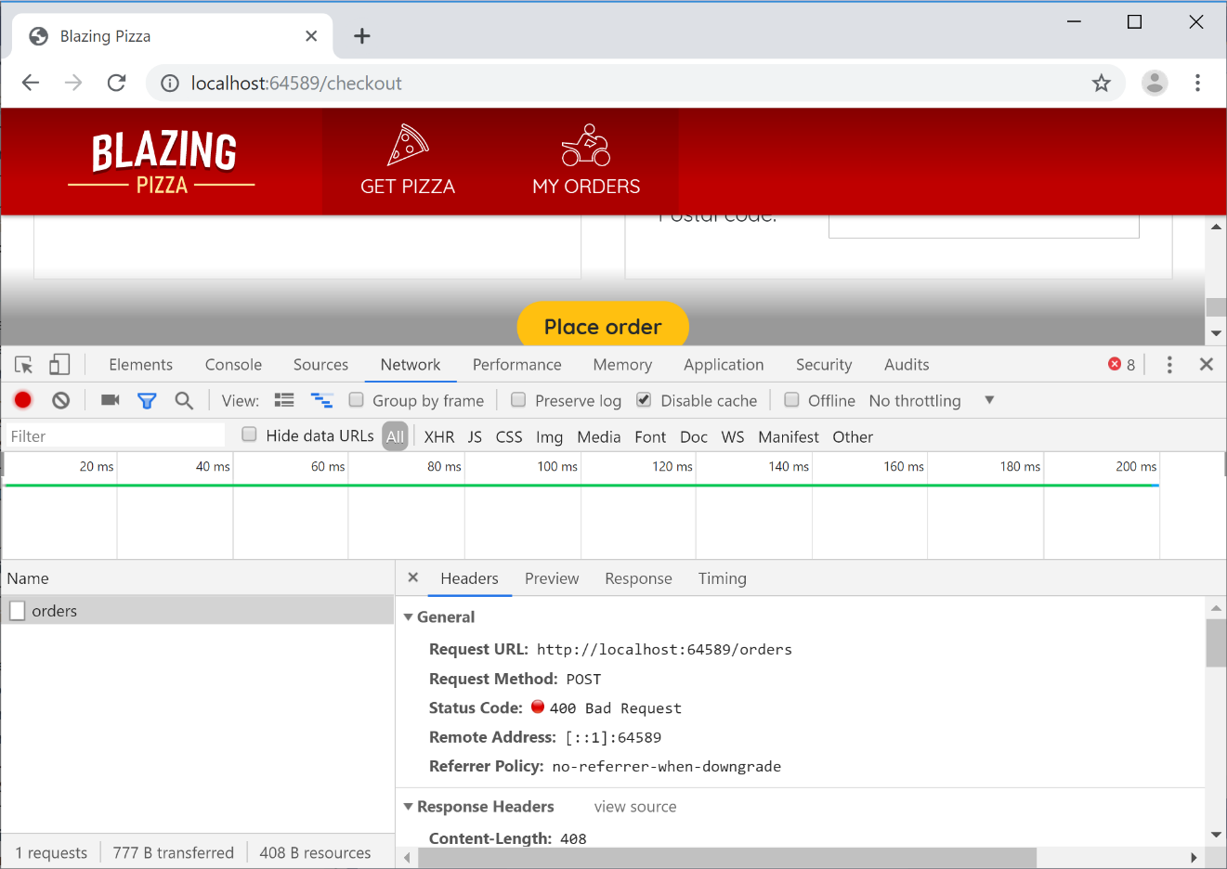](https://user-images.githubusercontent.com/1101362/59220316-93207080-8bbc-11e9-8bbb-f3f5ec8a29d6.png)

Task 3: Adding Client-side Validation

1. Blazor has a comprehensive system for data entry forms and validation. We'll now use this to apply the same DataAnnotations rules on the client that are already being enforced on the server.

The way Blazor's forms and validation system works is based around something called an EditContext. An EditContext tracks the state of an editing process, so it knows which fields have been modified, what data has been entered, and whether or not the fields are valid. Various built-in UI components hook into the EditContext both to read its state (e.g., display validation messages) and to write to its state (e.g., to populate it with the data entered by the user).

1. One of the most important built-in UI components for data entry is the EditForm. This renders as an HTML <form> tag, but also sets up an EditContext to track what's going on inside the form. To use this, go to your Checkout.razor component, and wrap an EditContext around the whole of the contents of the main div:

<div class="main">

<EditForm Model="OrderState.Order.DeliveryAddress">

<div class="checkout-cols">

... leave unchanged ...

</div>

<button class="checkout-button btn btn-warning" @onclick="PlaceOrder">

Place order

</button>

</EditForm>

</div>

You can have multiple EditForm components at once, but they can't overlap (because HTML's <form> elements can't overlap). By specifying a Model, we're telling the internal EditContext which object it should validate when the form is submitted (in this case, the delivery address).

1. Let's start by displaying validation messages in a very basic (and not very attractive) way. Inside the EditForm, right at the bottom, add the following two components:

<DataAnnotationsValidator />

<ValidationSummary />

The DataAnnotationsValidator hooks into events on the EditContext and executes DataAnnotations rules. If you wanted to use a different validation system other than DataAnnotations, you'd swap DataAnnotationsValidator for something else.

The ValidationSummary simply renders an HTML <ul> containing any validation messages from the EditContext.

1. If you ran your application now, you could still submit a blank form (and the server would still respond with an HTTP 400 error). That's because your <button> isn't actually a submit button. Modify the button by adding type="submit" and **removing** its @onclick attribute entirely.

Next, instead of triggering PlaceOrder directly from the button, you need to trigger it from the EditForm. Add the following OnValidSubmit attribute onto the EditForm:

<EditForm Model="OrderState.Order.DeliveryAddress" OnValidSubmit="PlaceOrder">

As you can probably guess, the <button> no longer triggers PlaceOrder directly. Instead, the button just asks the form to be submitted. And then the form decides whether or not it's valid, and if it is, then it will call PlaceOrder.

1. Try it out: you should no longer be able to submit an invalid form, and you'll see validation messages (albeit unattractive ones).

[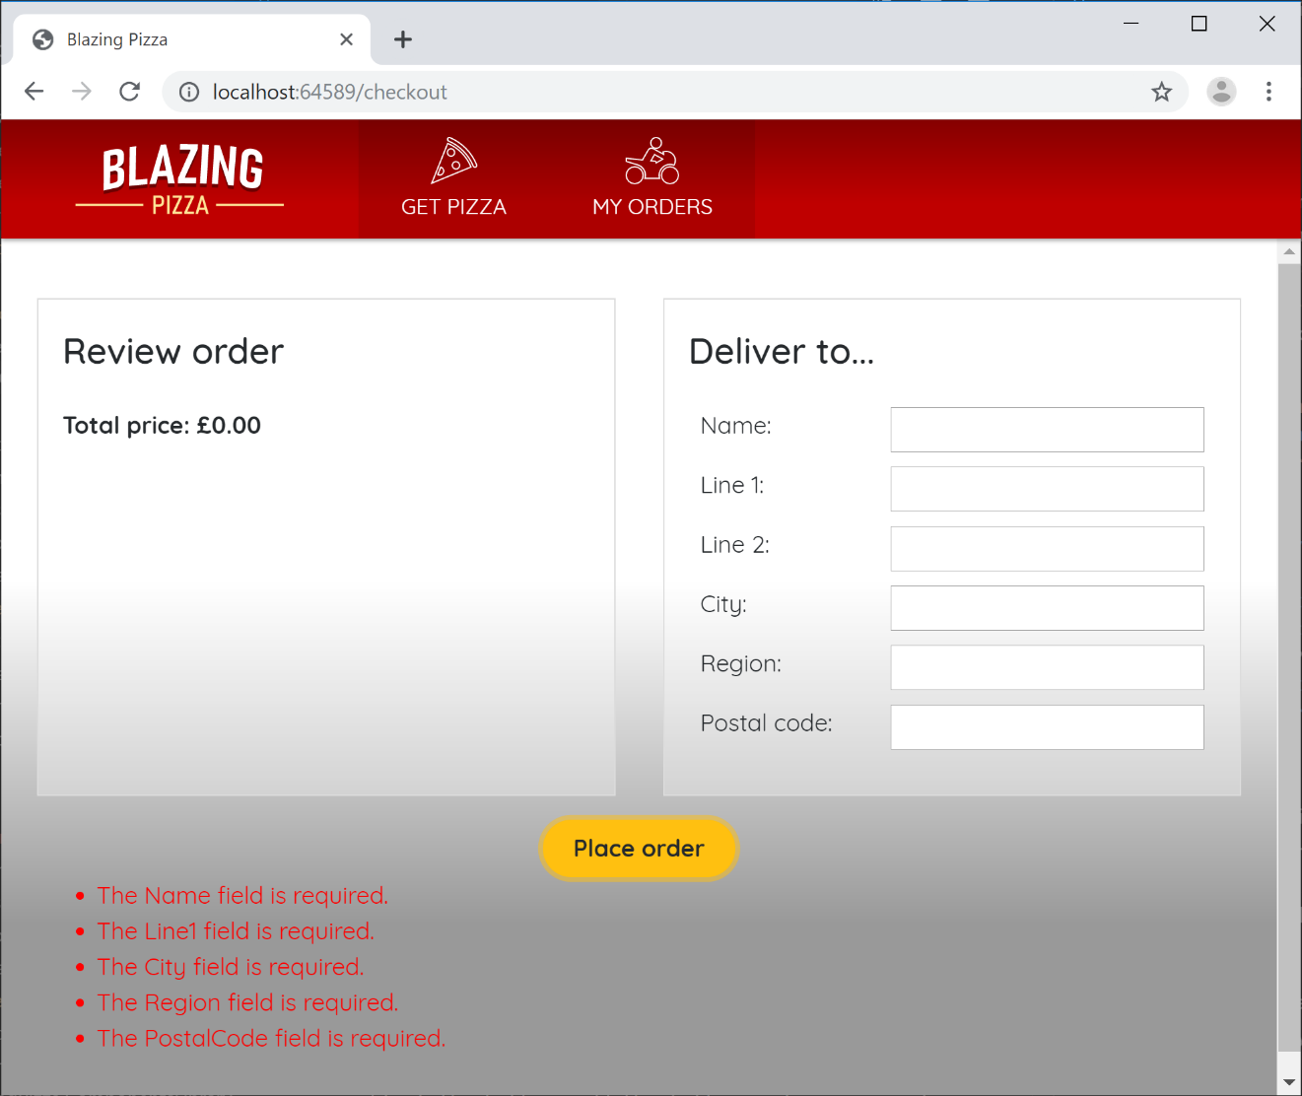](https://user-images.githubusercontent.com/1101362/59221577-85201f00-8bbf-11e9-9de6-f24f93a6a483.png)

1. Obviously it's not clean to display all the validation messages so far away from the textboxes. Let's move them to better places.

Start by removing the <ValidationSummary> component entirely. Then, switch over to AddressEditor.razor, and add separate <ValidationMessage> components next to each of the form fields. For example,

<div class="form-field">

<label>Name:</label>

<div>

<input @bind="Address.Name" />

<ValidationMessage For="@(() => Address.Name)" />

</div>

</div>

1. Do the equivalent for all of the form fields.

In case you're wondering, the syntax @(() => Address.Name) is a *lambda expression*, and we use this syntax as a way of describing which property to read the metadata from, without actually evaluating the property's value.

Now things look a lot better:

[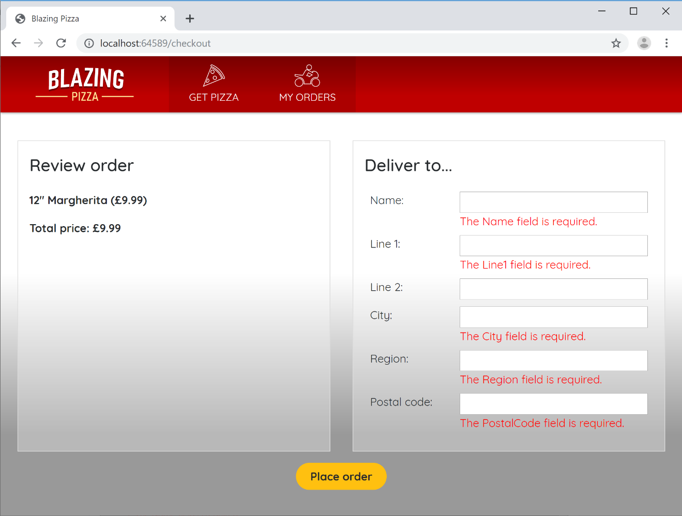](https://user-images.githubusercontent.com/1101362/59221927-4b034d00-8bc0-11e9-96ef-6c41ad727cb7.png)

1. If you want, you can improve the readability of the messages by specifying custom ones. For example, instead of displaying The City field is required, you could go to Address.cs and do this:

[Required(ErrorMessage = "How do you expect to receive the pizza if we don't even know what city you're in?"), MaxLength(50)]

public string City { get; set; }

Task 4: Better Validation UX Using The Built-In Input Components

1. The user experience is still not great, because once the validation messages are displayed, they remain on the screen until you click *Place order* again, even if you have edited the field values. Try it out and see how it feels pretty basic!

To improve on this, you can replace the low-level HTML input elements with Blazor's built-in input components. They know how to hook more deeply into the EditContext:

* When they are edited, they notify the EditContext immediately so it can refresh validation status.
* They also receive notifications about validity from the EditContext, so they can highlight themselves as either valid or invalid as they user edits them.

1. Go back to AddressEditor.razor once again. Replace each of the <input> elements with a corresponding <InputText>. For example,

<div class="form-field">

<label>Name:</label>

<div>

<InputText @bind-Value="Address.Name" />

<ValidationMessage For="@(() => Address.Name)" />

</div>

</div>

Do this for all the properties. The behavior is now much better! As well as having the validation messages update individually for each form field as you change focus, you'll get a neat "valid" or "invalid" highlight around each one:

[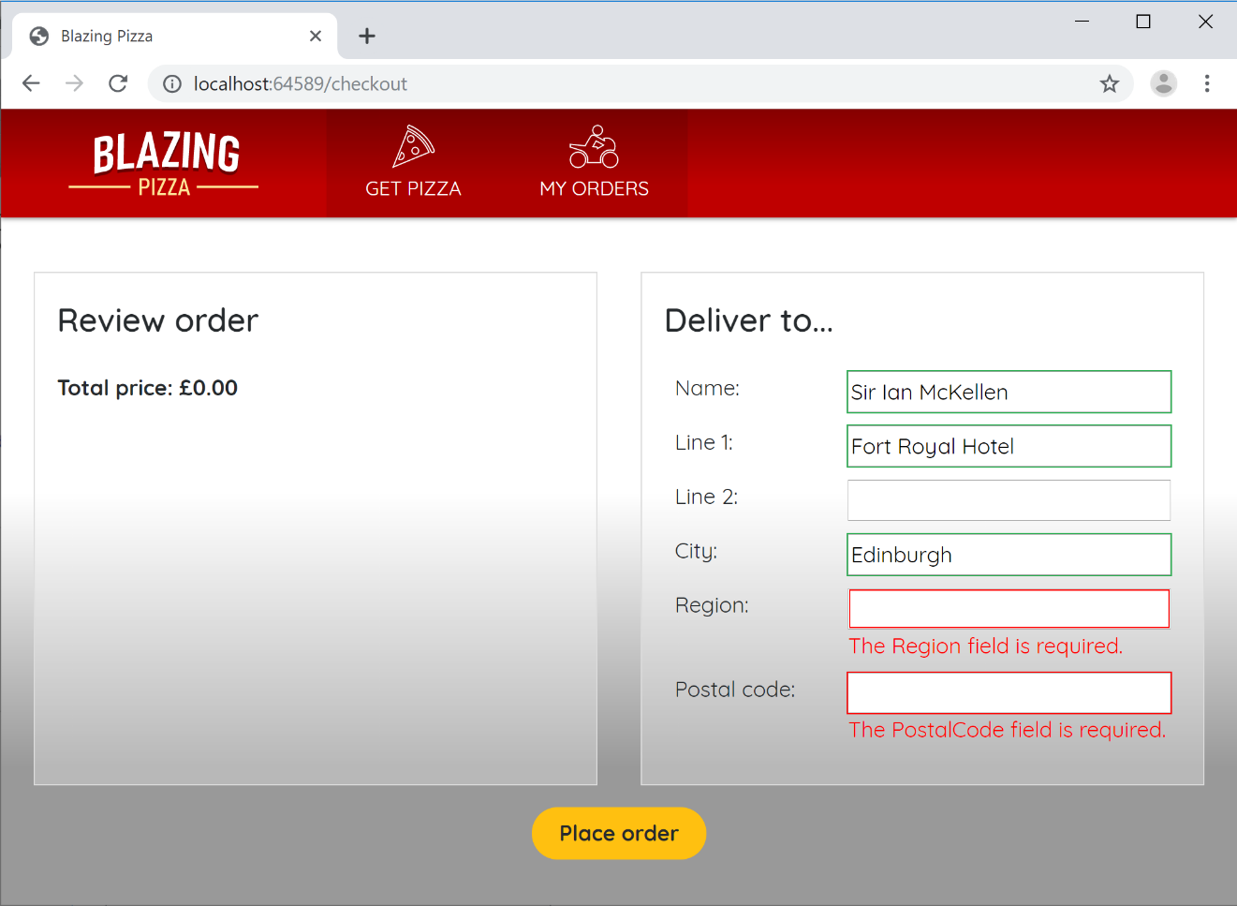](https://user-images.githubusercontent.com/1101362/59222864-6a9b7500-8bc2-11e9-9f90-ae1d47fc23d7.png)

The green/red styling is achieved by applying CSS classes, so you can change the appearance of these effects or remove them entirely if you wish.

InputText isn't the only built-in input component, though it is the only one we need in this case. Others include InputCheckbox, InputDate, InputSelect, and more.